**Review of the Apple M1 Pro**

Today, we are taking benchmarking to new heights by looking at an Apple Silicon product. We bought a new Apple MacBook Pro16 powered with the M1 Pro SoC a few weeks back and have been testing it out ever since.

This review will compare the M1 Pro to the most powerful x86-based CPUs available from Intel and AMD. We don't mean to run Geekbench all day. We won't actually be running Geekbench, but we will run a variety of multi-platform real-world applications, comparing their performance under different conditions.

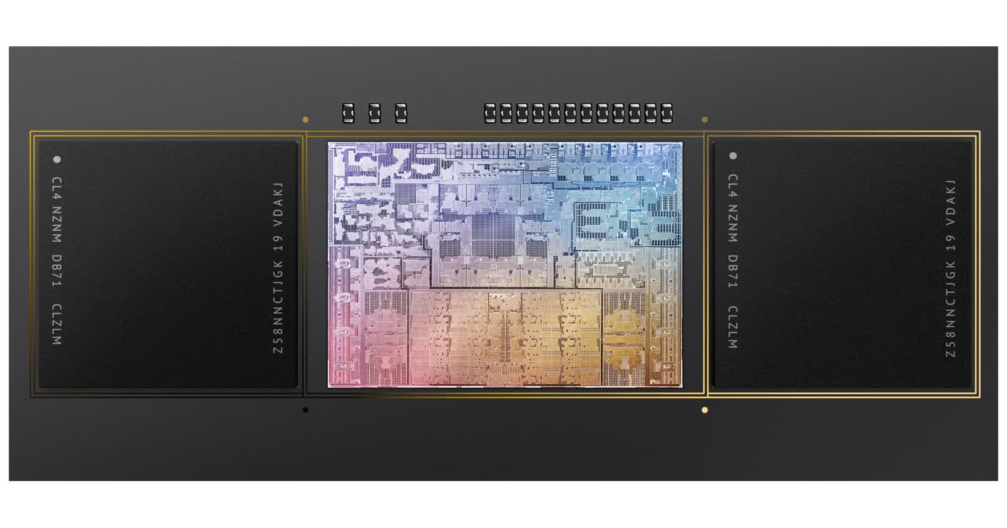

This will be an interesting discussion because [Apple M1 Silicon](https://www.techspot.com/news/91275-learn-all-about-apple-m1-350-page-deep.html) has been the subject of a lot hype. It's also likely that there is a lot of talk about its desktop-destroying capabilities. Hype is often overhyped and there's a lot fanboyism. We'll find out how justified all that hype is today.

The Apple M1 Pro SoC design is very different from the ones we usually review. It uses [the Arm architecture](https://www.techspot.com/article/1989-arm-inside/) instead of x86. It doesn't make it better. But it does approach things differently. The processor's core contains a maximum of 10 CPU cores. These cores are split into 8 Firestorm cores that are highly efficient and 2 Icestorm cores that are efficient in a hybrid design. Firestorm cores can clock up to 3.2 GHz while Icestorm cores reach 2.1 GHz. However, this is dependent on how much load is placed on the system. All-core workloads reduce those clocks by a few hundred MHz.

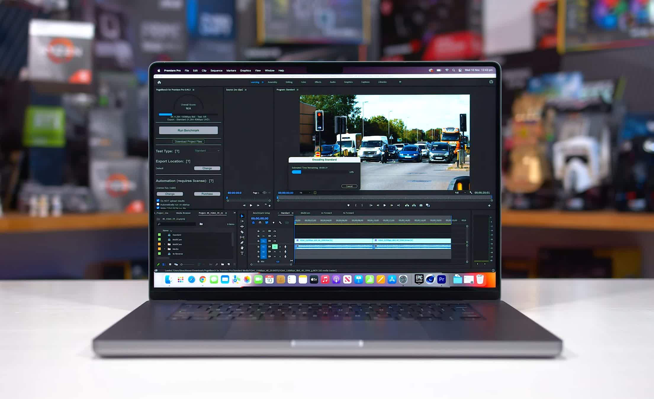

The GPU design includes a 16-core M1 Pro design, which can be upgraded to 32 cores by the M1 Max (which comes in a more costly version of the same laptop). A 256-bit wide LPDDR5 bus provides slightly more than 200 GB/s and connects to the CPU and GPU. This is similar to an x86 design that includes quad-channel memory. The M1 Pro also has a lot of L2 cache, and 24 MB top-level cache. To feed the larger GPU, both the top-level cache and memory controllers have been doubled on M1 Max.

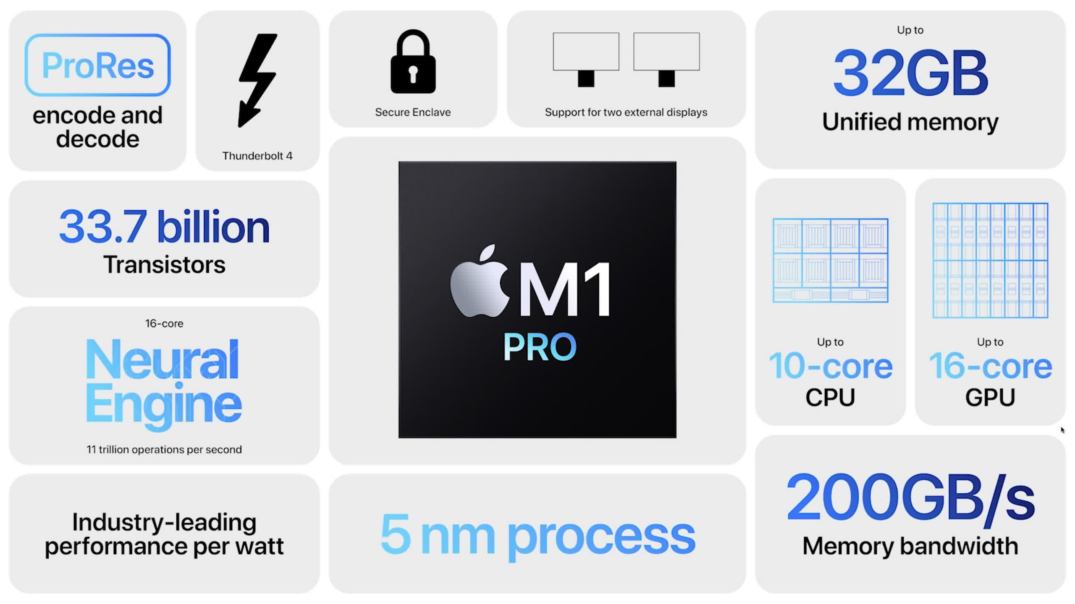

Apple has followed Nvidia's lead in calling the M1 Pro by releasing two variants with the same moniker. The top-level architecture has a complete 10-core CPU and 16-core GPU, but the base design has just 8 CPU cores and 14 GPU cores. While this is prominently shown on Apple's product website for MacBook Pros, the actual product name isn't differentiated beyond M1 Pro.

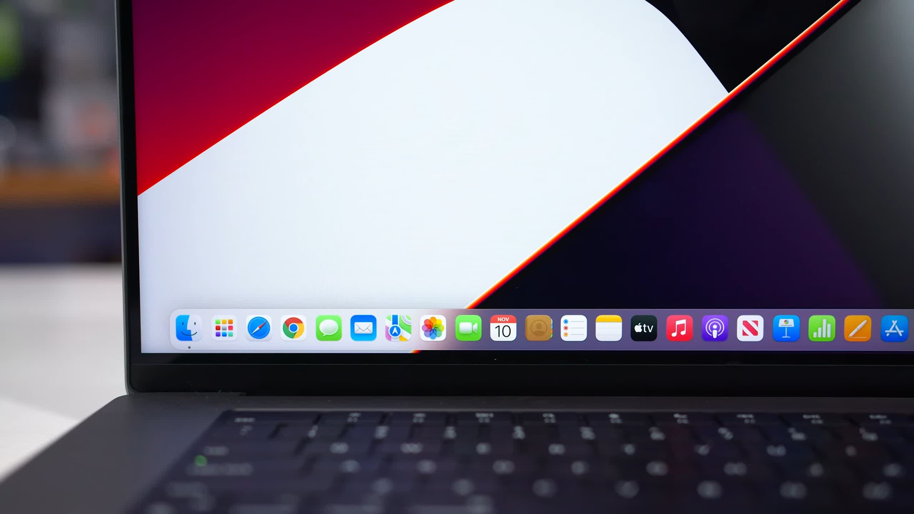

We purchased a 16 inch MacBook Pro with full M1 Pro configuration for our testing. To match our laptop test data which uses 16GB RAM and a 512GB SSD, we also selected 16GB of unified storage. Apple's storage upgrades are horrendously expensive. It would have cost £438 more to increase that to 32GB and 1TB. These components can't be upgraded by you, so you will have to pay these prices if your needs are greater than the ones provided by Apple.

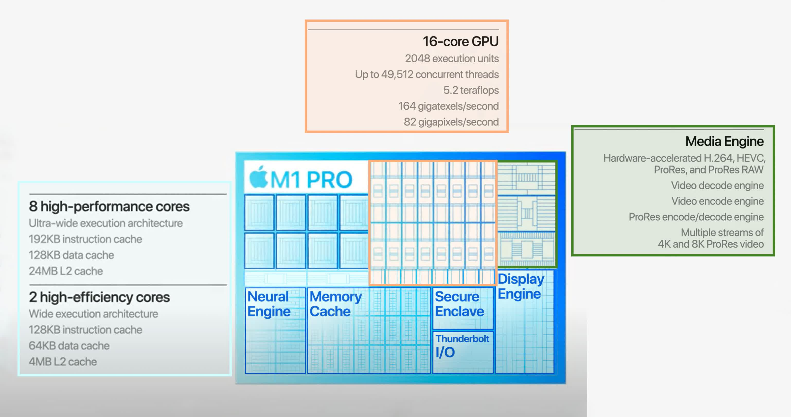

Today's testing will be done by comparing the M1 Pro with our data for AMD and Intel CPUs. This is all power normalized to their default TDPs. We've been working on additional challenges over the past week. Not all the applications we benchmark are compatible with macOS. We'll only include cross-platform benchmarks that have a macOS version. This could be a native ARM or x86 version emulated by Apple Silicon via Rosetta 2.

This introduces an additional variable, in that the Windows and macOS apps will operate slightly differently. However, it's the best thing we can do considering the circumstances. Let's move on to the testing.

**Benchmarks**

The M1 Pro is marginally quicker than the next fastest CPU we've tested, the Ryzen 9 5900HX, in Cinebench R23 multi-threading, which is a native Apple Silicon software. The M1 Pro was 4 percent faster during a 10-minute period, but it also consumed less power, as we'll discuss later.

The M1 Pro is closer to a 35W CPU than the 5900HX, which uses 45W; the M1 Pro is 12 percent quicker than AMD's top 35W CPU, the Ryzen 9 5980HS, which is probably more equivalent. The M1 Pro is 14 percent quicker than Intel's top chip at 45W, the Core i9-11980HK, giving Apple an even bigger edge over Intel.

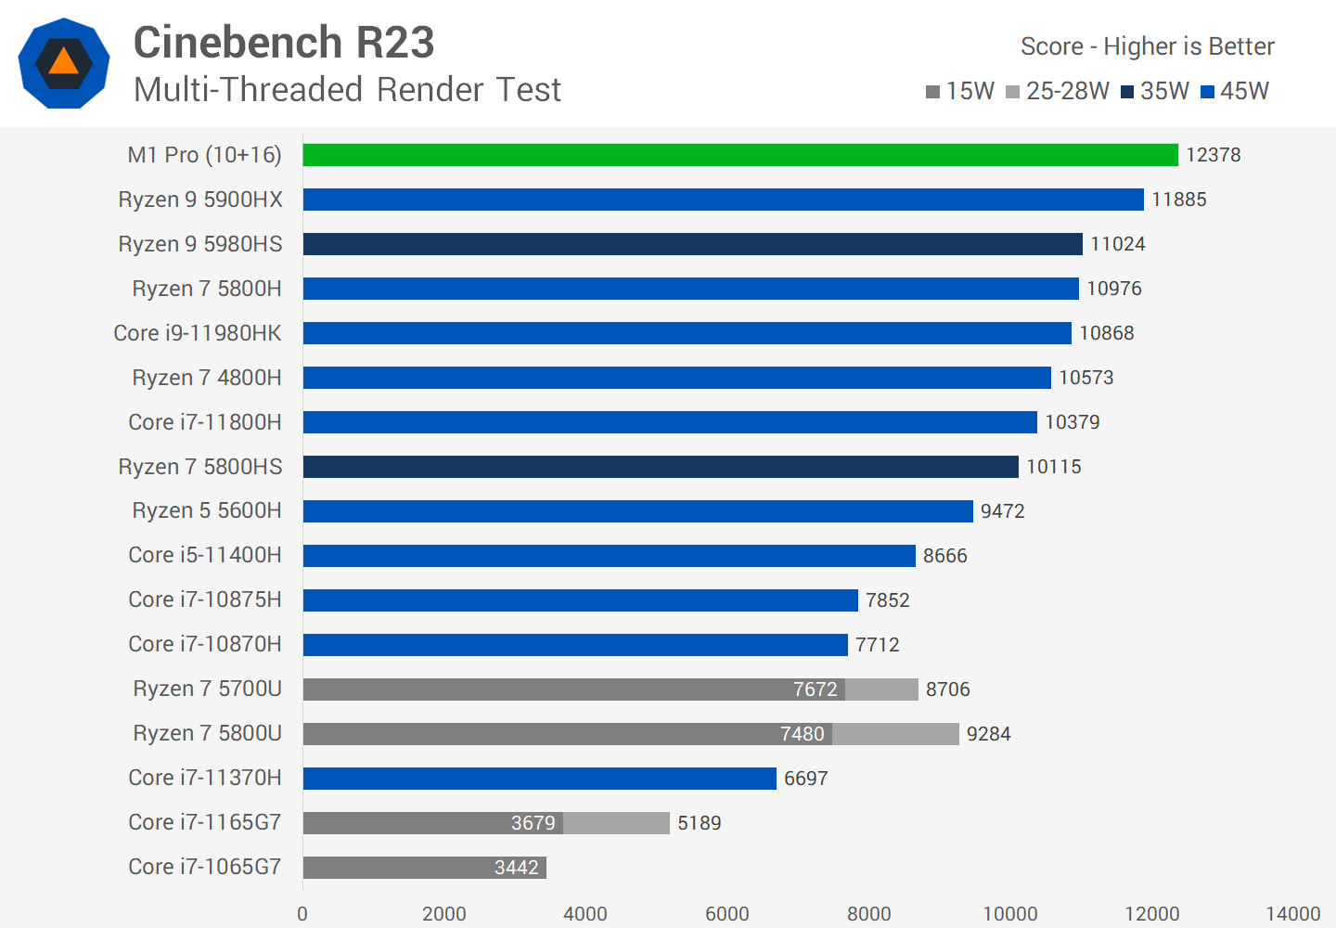

The Intel Core i7-10875H is also worth mentioning. This CPU performs similarly to the 9th-gen Core i9-9980HK, which was available in the top 2019 MacBook Pro models in terms of multi-thread performance. In this benchmark, the M1 Pro is approximately 60% quicker, which is why Apple consumers are pleased about the speed boost with this new generation of Apple silicon.

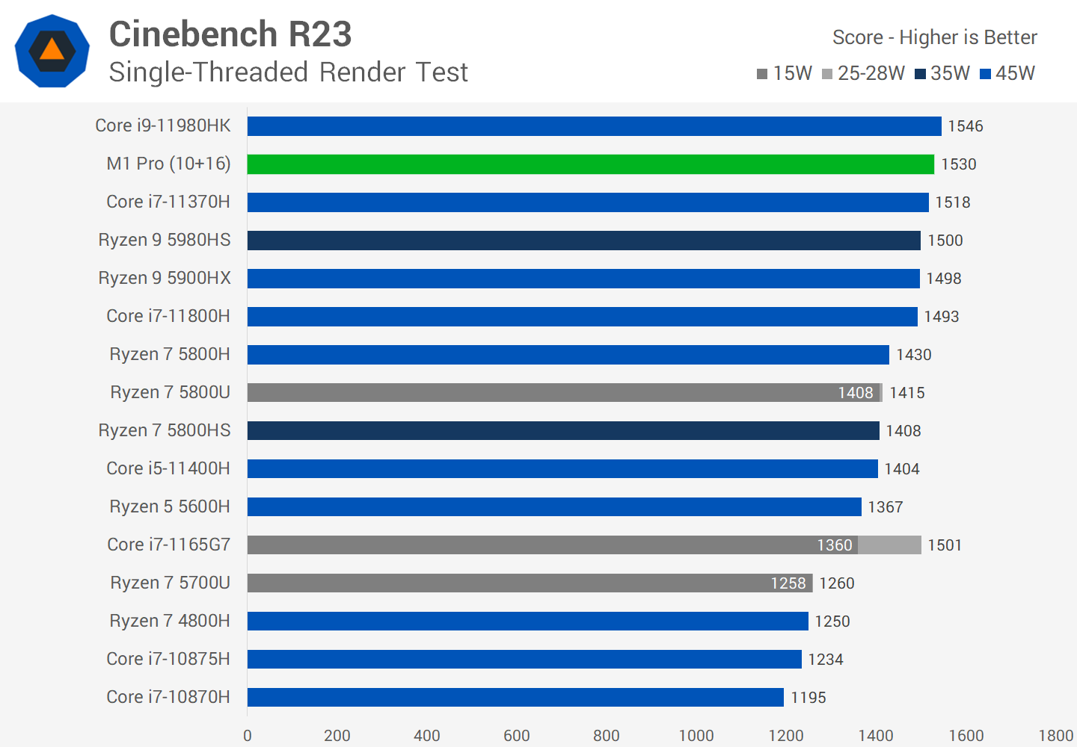

In terms of single thread performance, there isn't much to choose between the M1 Pro and the top Intel or AMD CPUs. Apple's chip is sandwiched between the Ryzen 9 5980HS and the Core i9-11980HK, making these CPUs a bit of a toss-up in this task. However, performance is more than 20% quicker than those of Apple's prior Intel CPUs.

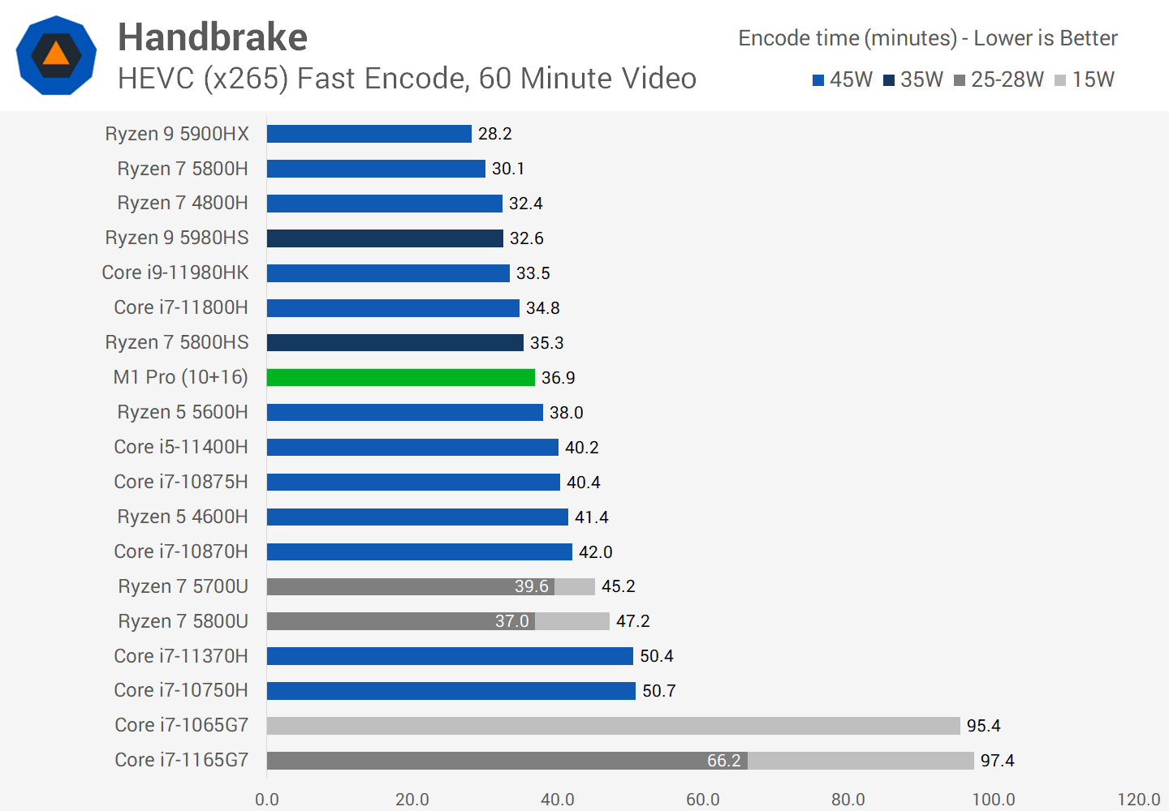

Handbrake is a native Apple Silicon software for macOS that demonstrates CPU-based x265 video encoding. Although this software runs natively on the M1 Pro, it greatly benefits from AVX instructions on x86-based CPUs. As a result, when compared to x86 counterparts like the Ryzen 9 5980HS or Core i9-11980HK, the M1 Pro falls short. While the M1 Pro's performance isn't awful, it trails Intel's finest Core i9 CPU by 9% and AMD's best Ryzen 9 processor by 24%, despite Apple's reduced power usage.

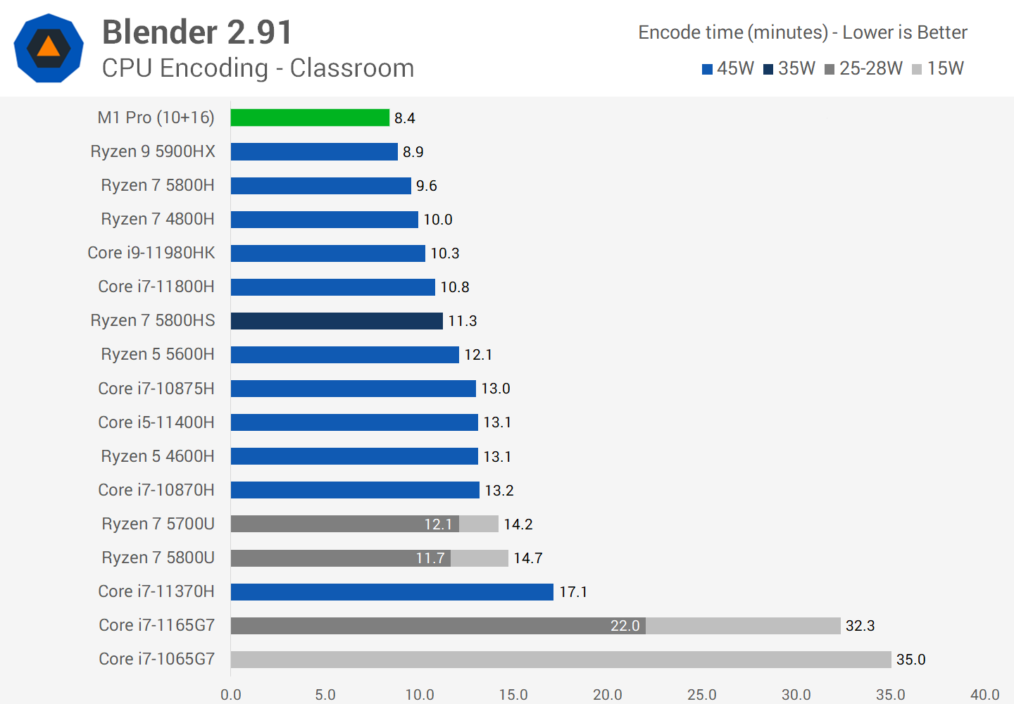

The M1 Pro is a strong CPU for Blender rendering on the CPU, exceeding Intel and AMD's top CPUs. Although the performance advantage over the Ryzen 9 5900HX is only 5%, it is a significant 23 percent quicker than the 11980HK. The primary difficulty with Blender on MacBooks is that, while the software is natively accessible for Apple Silicon, it does not allow GPU rendering. GPU rendering utterly obliterates the M1 Pro when utilising an RTX 3050 with Optix, with performance over 3x quicker. MacBook Pros are not the greatest option till Blender is upgraded with GPU support.

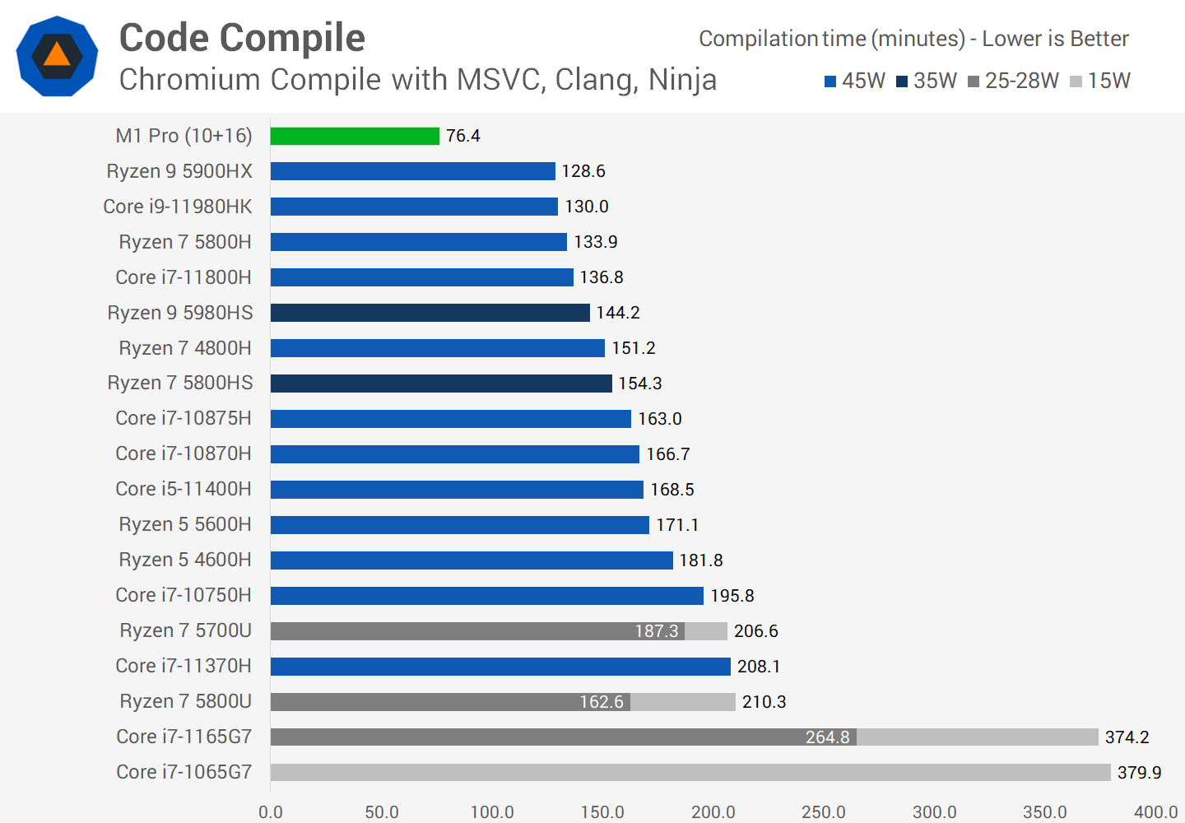

While the M1 Pro has so far been able to compete with the finest x86 CPUs in rendering and encoding tests, Apple Silicon has a significant edge when it comes to code compilation. I should mention that we benchmarked constructing the Windows version on Windows and the Mac version on macOS for our Chromium compilation, following Google's suggested approach for each OS. Unfortunately, despite the fact that Intel Macs can create the Windows version, I was unable to get the MacBook Pro to do so. So, while my benchmark wasn't quite apples-to-apples, it's still a realistic use case in my perspective.

In any event, the M1 Pro outperforms its x86 counterparts, with compilation times 68 percent quicker than the Ryzen 9 5900HX, the next quickest device we tested. In this workload, the M1 Pro has a significant advantage, thanks to its high memory bandwidth, which is more than twice that of the other laptops in these figures. I believe these new MacBooks will be ideal for programmers.

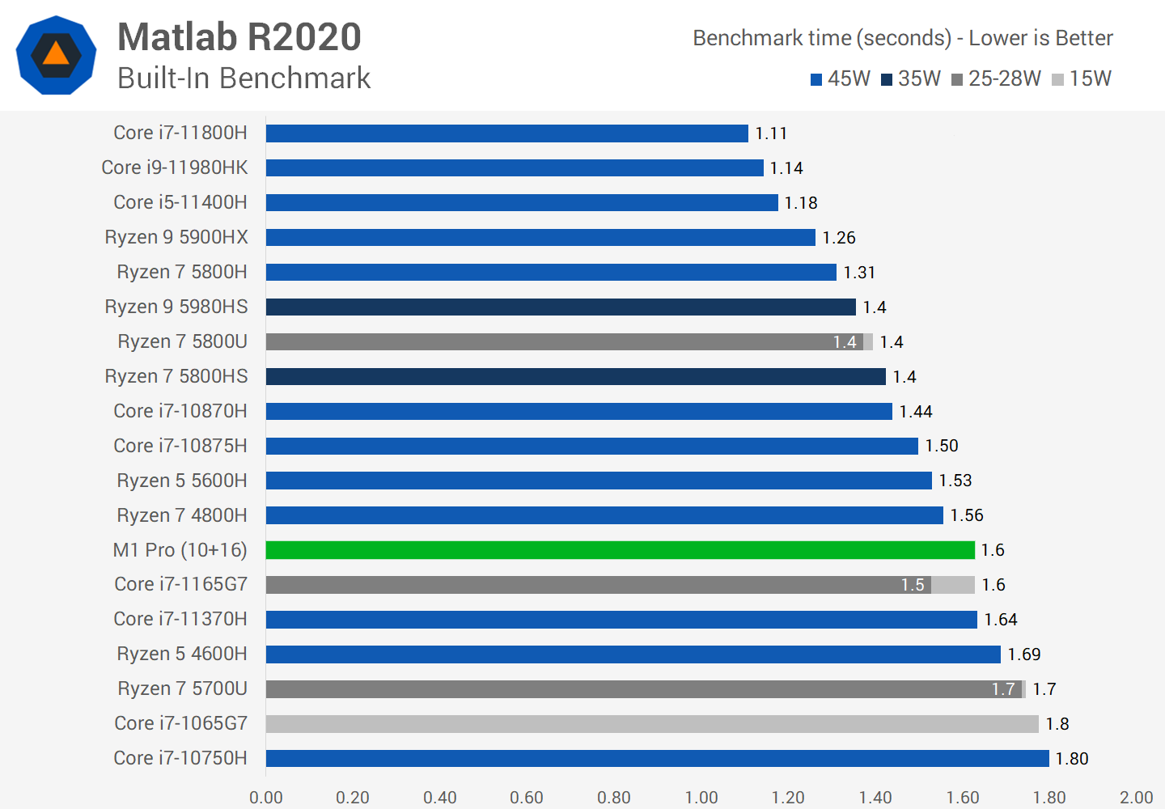

For the time being, Matlab is only available via Rosetta 2 emulation, and as a result, performance on the M1 Pro suffers. The SoC is roughly similar to a Ryzen 7 4800H CPU or an Intel Core i7-1165G7 CPU, both of which are respectable processors but not the fastest currently available. In this software, the M1 Pro is 30% slower than Intel's Core i9-11980HK, thus you're better off utilising a contemporary Windows PC for your engineering job in Matlab for the time being.

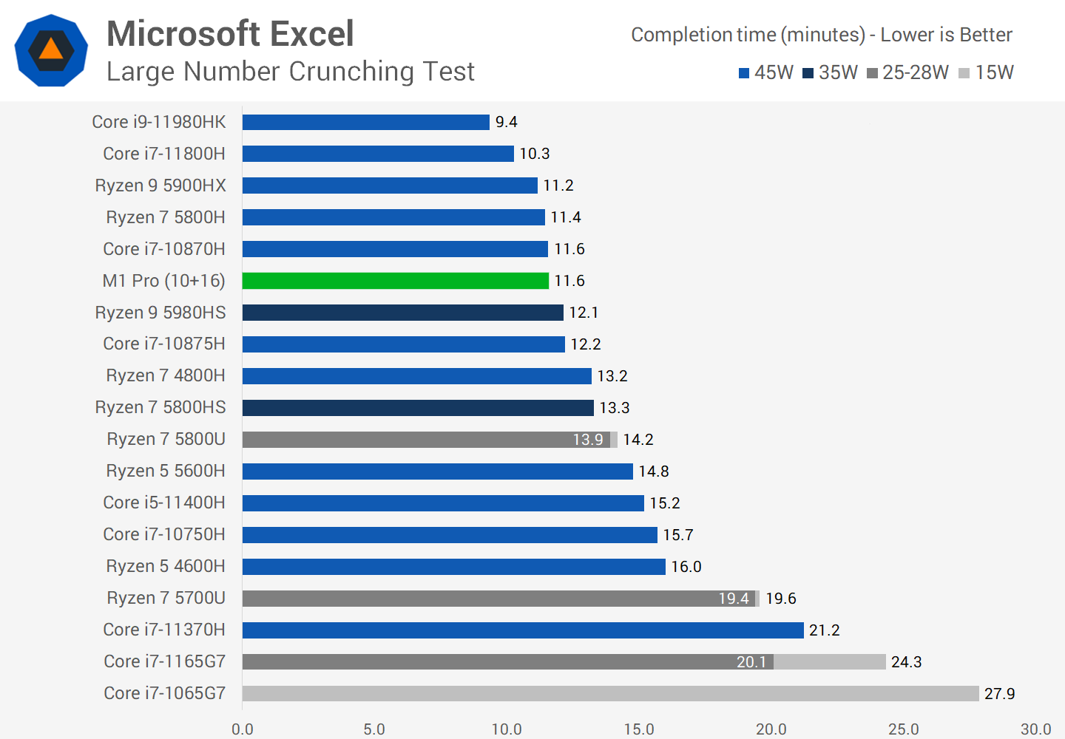

Microsoft Excel is natively accessible on Apple Silicon, and it performs admirably in our number crunching test. The M1 Pro is somewhat quicker than the fastest 35W CPU we've tested, the Ryzen 9 5980HS, but it can't compete with the finest x86 mobile processors. The Core i9-11980HK is 23% quicker, while the Ryzen 9 5900HX comes out on top.

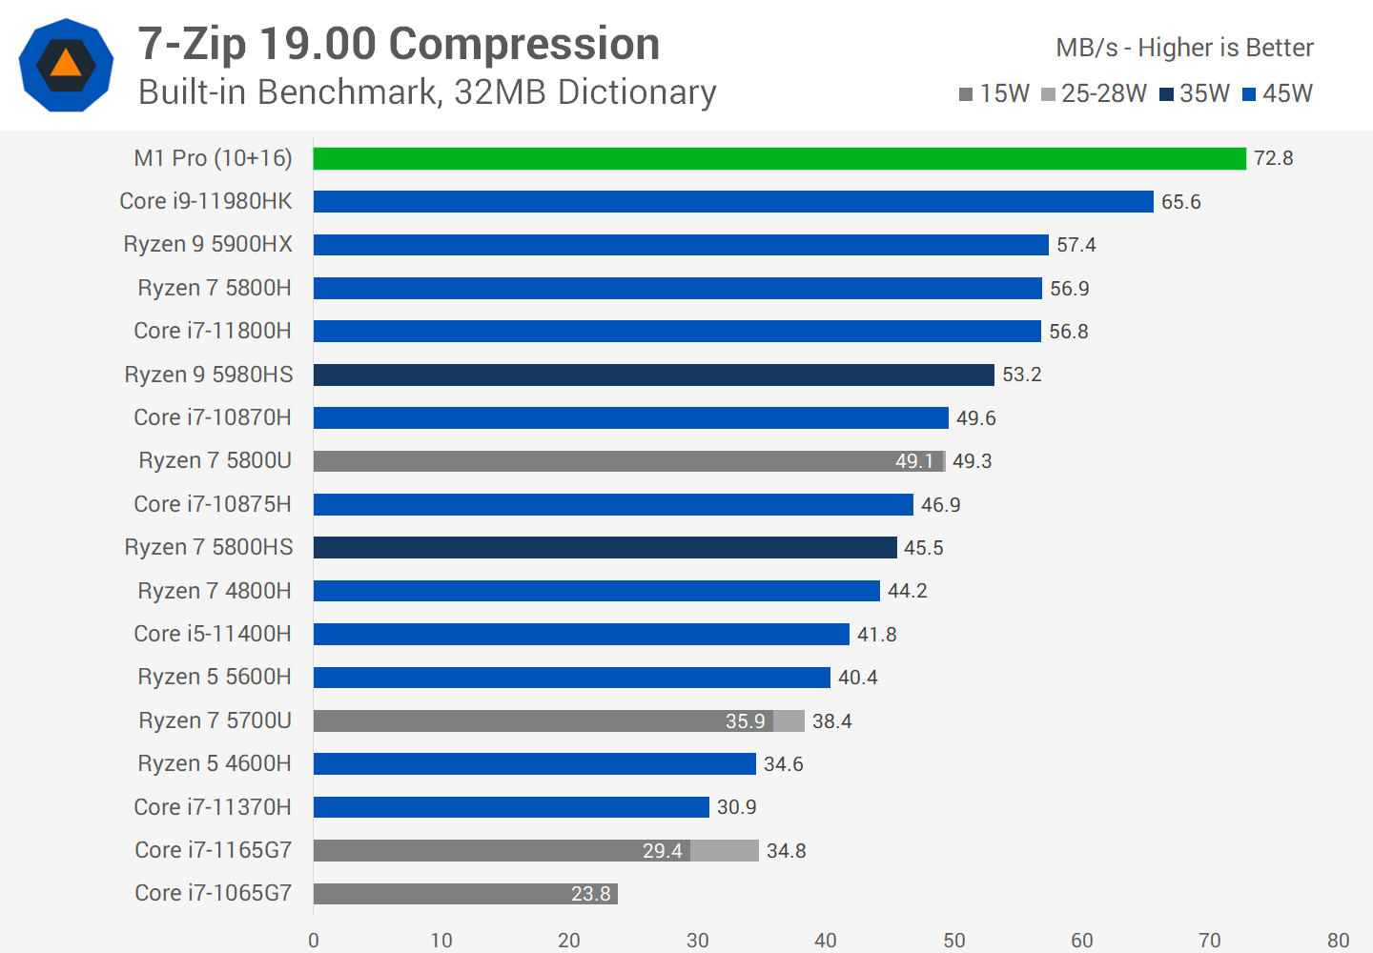

When comparing the native Apple Silicon version of 7-Zip compression against the same test on Windows, the M1 Pro is a beast. Despite utilising substantially less power in this burst task, the M1 Pro is 11 percent quicker than the i9-11980HK, and 27 percent faster than AMD's best showing, the 5900HX.

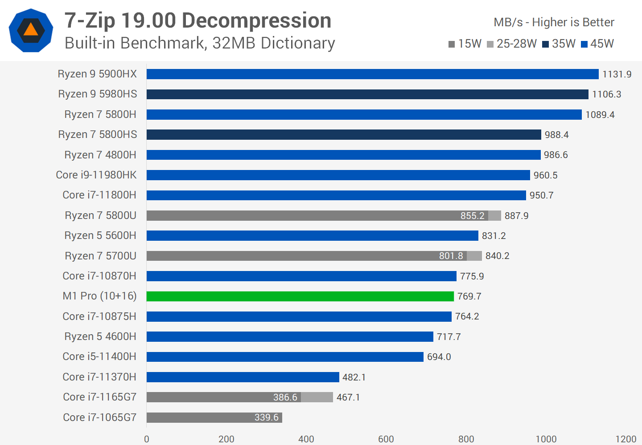

When employing 7-zip decompression, however, the tables are turned. On x86 CPUs, this benchmark likes simultaneous multi-threading, and it's especially fast on Zen, so it has a significant advantage over the M1 Pro. This is a poor performance for Apple Silicon, since it is 32% slower than the Ryzen 9 5900HX and more in line with Intel's 10th-generation CPUs.

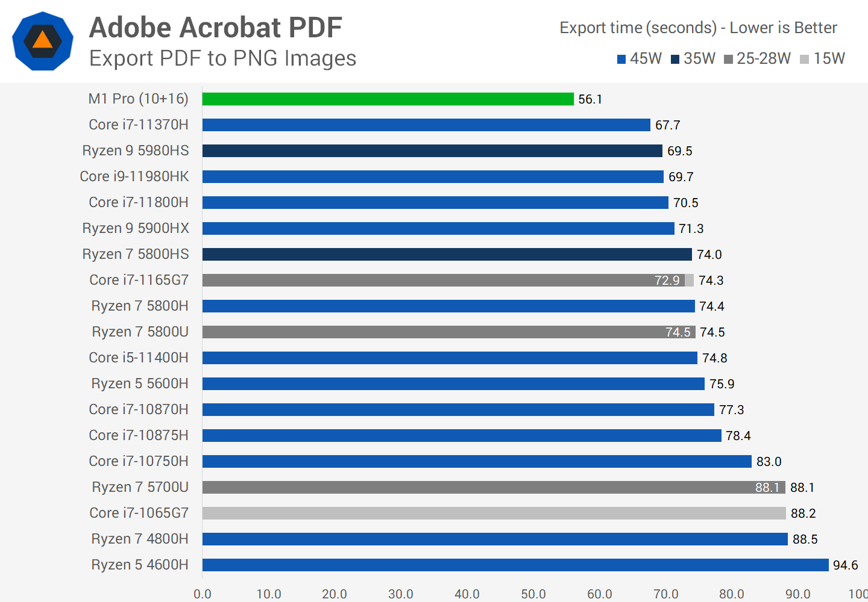

Acrobat Pro is only available on macOS via Rosetta 2 emulation, and PDF exporting is a single-threaded programme. But don't worry: the M1 Pro still outperforms its x86 competitors, with performance that is up to 25% quicker than the best AMD or Intel has to offer.

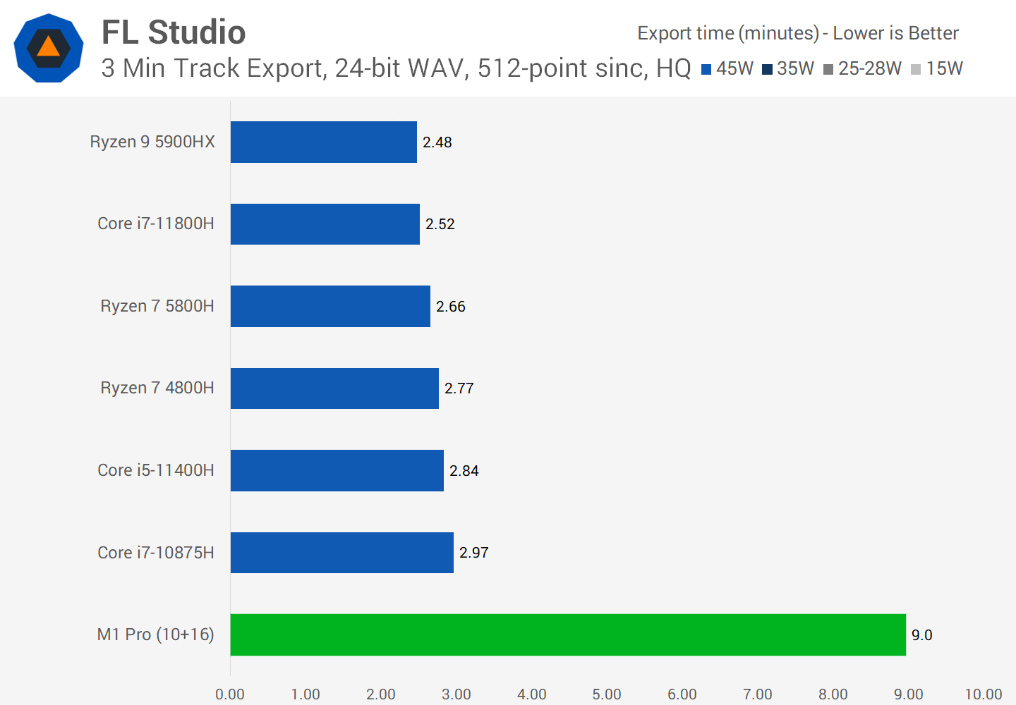

FL Studio is a new addition to our benchmarks that we've been experimenting with for a while. Although there is a native Apple version of the programme, it performs poorly on the M1 Pro. I double-checked this since it seemed too good to be true compared to our Windows-based systems, but it's the current version of the programme exporting the default track. Despite the fact that the MacBook Pro's CPU was at 100% during the track export, I believe something is wrong with this software and it needs substantial development on macOS.

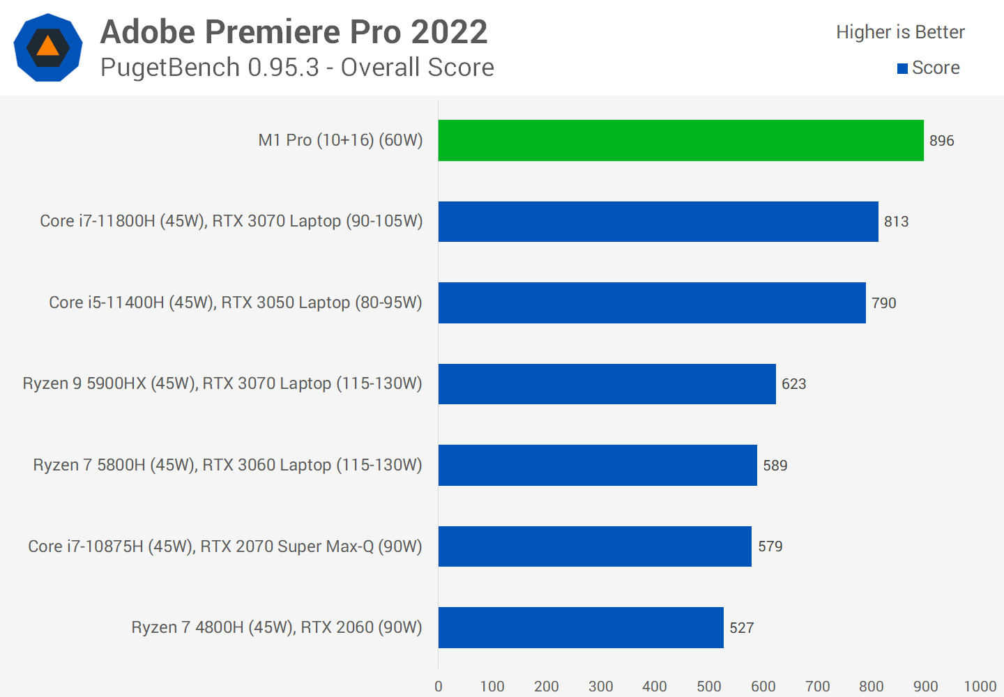

We've updated our Adobe Premiere benchmarks to reflect the most recent 2022 version, which works natively on Apple Silicon. Using the most recent version of PugetBench, the M1 Pro appears to surpass even the most competent Windows computers, such as one with a 11800H and RTX 3070 combo. This is unquestionably a fantastic result, but let's go a little further into the subscores.

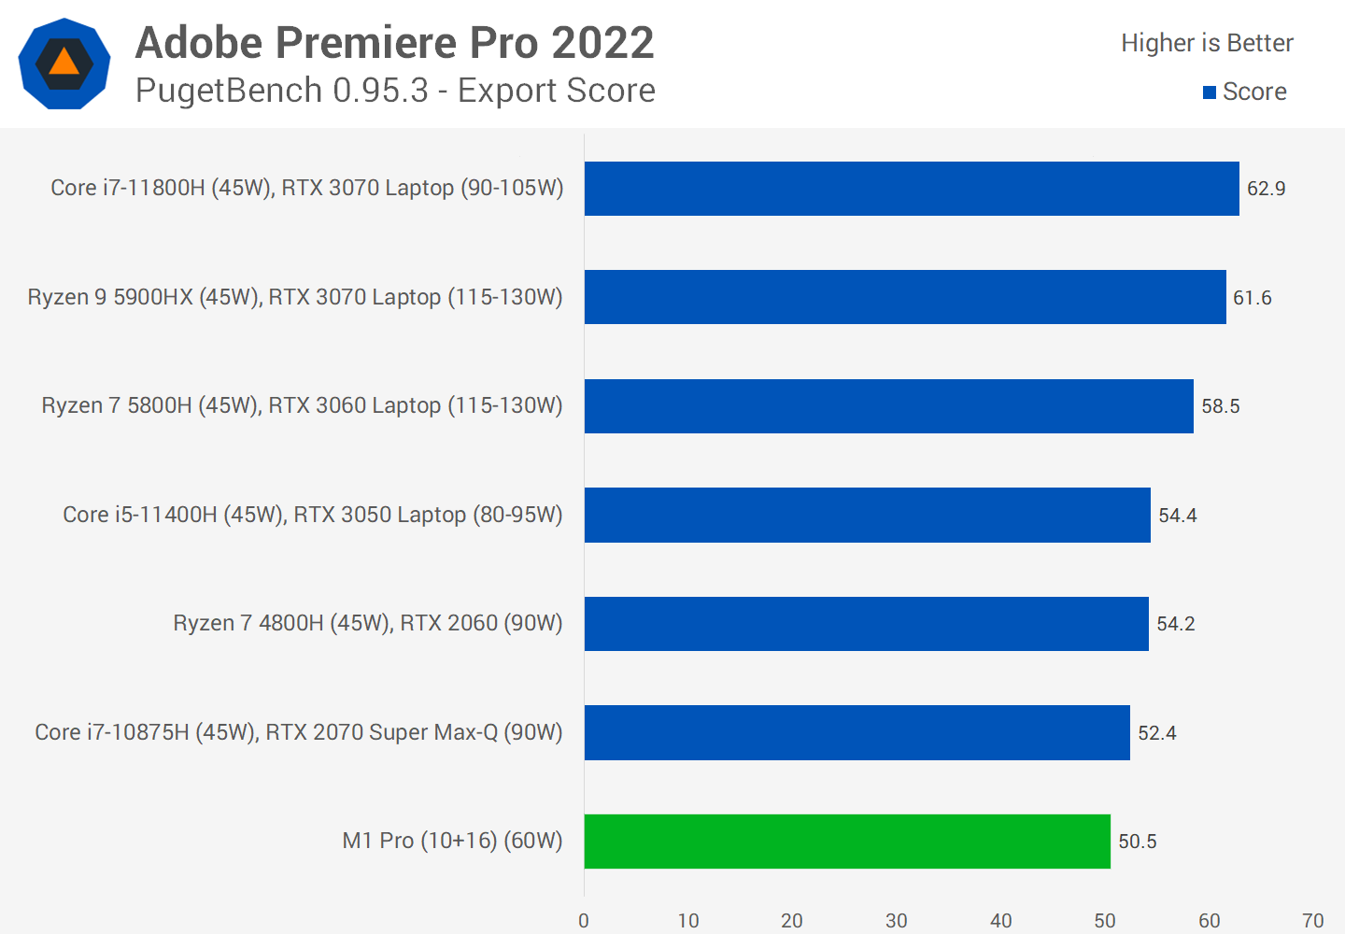

When it comes to exporting, Premiere's result is comparable to what we observed before when we benchmarked Handbrake, in that the M1 Pro isn't the most remarkable product. PugetBench employs a mix of outputs, and while the SoC supports a variety of hardware-accelerated encoding options, Nvidia GPUs excel at accelerated encoding and hence perform admirably in this test.

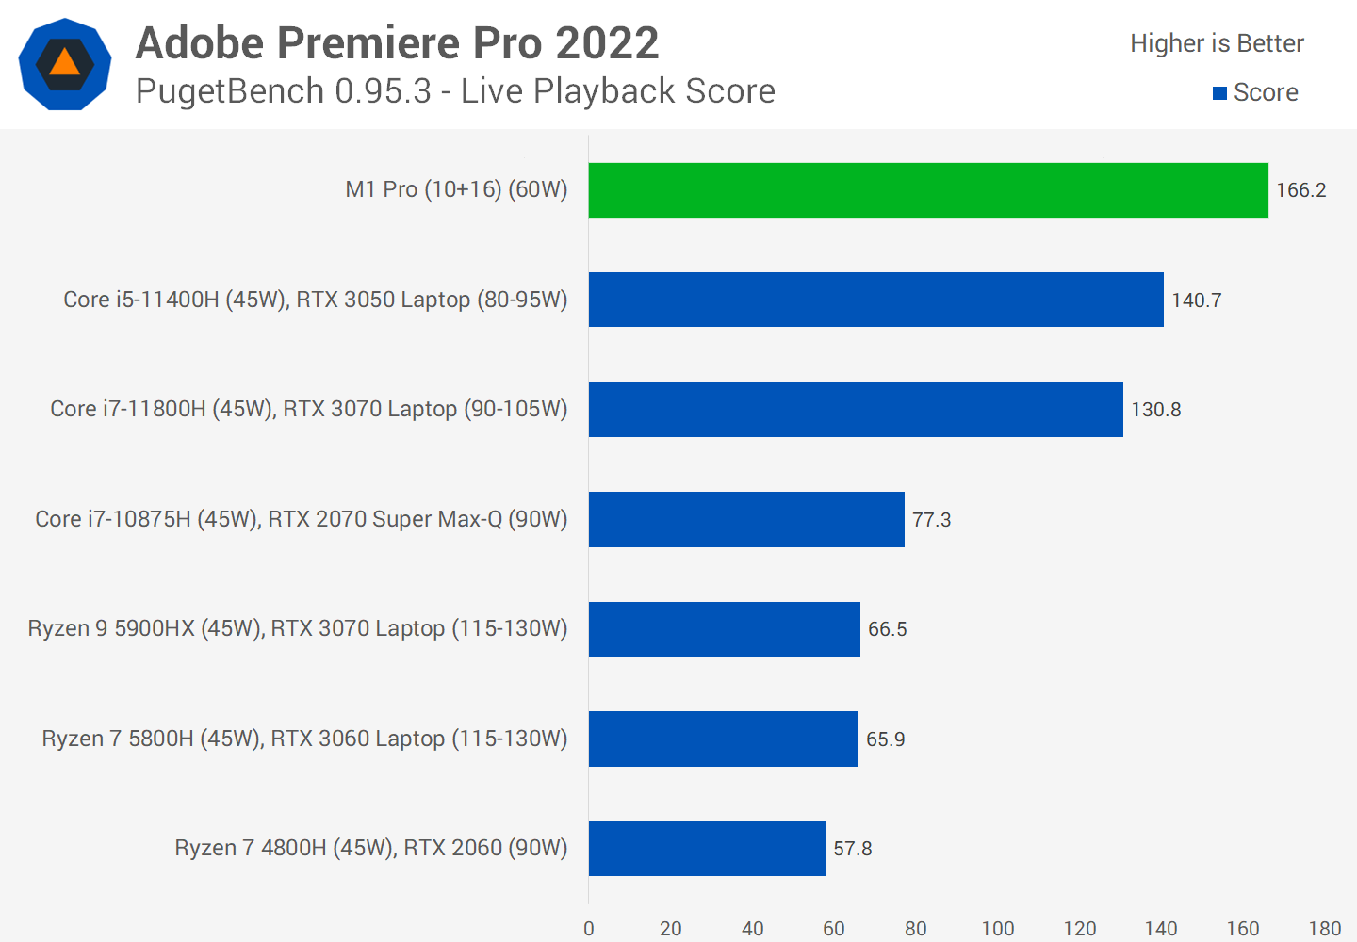

Apple has a stronghold in live playback, which relates to how smoothly film moves along the timeline. The M1 Pro outperforms comparable solutions thanks to features like hardware accelerated ProRes, and 11th-gen Intel-based workstations also perform well thanks to excellent decoding support with their iGPU.

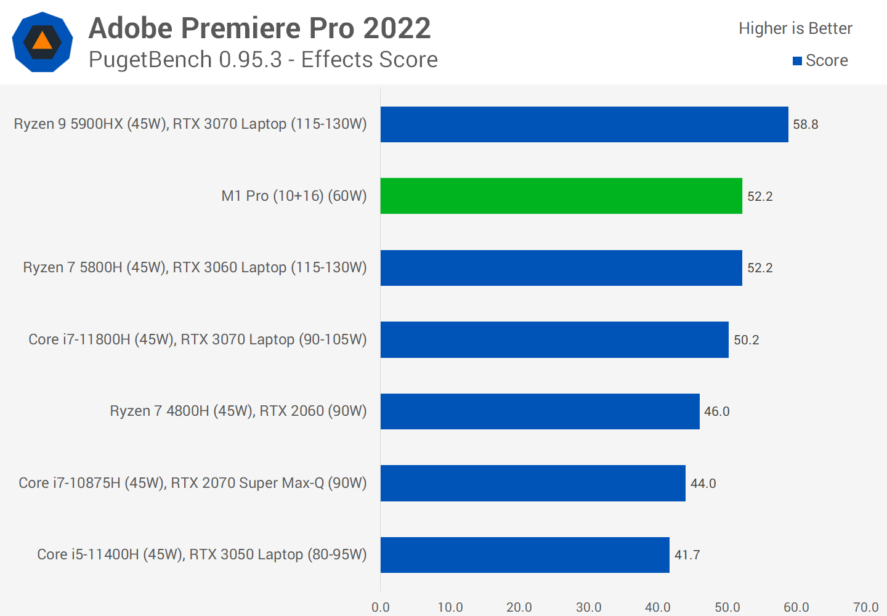

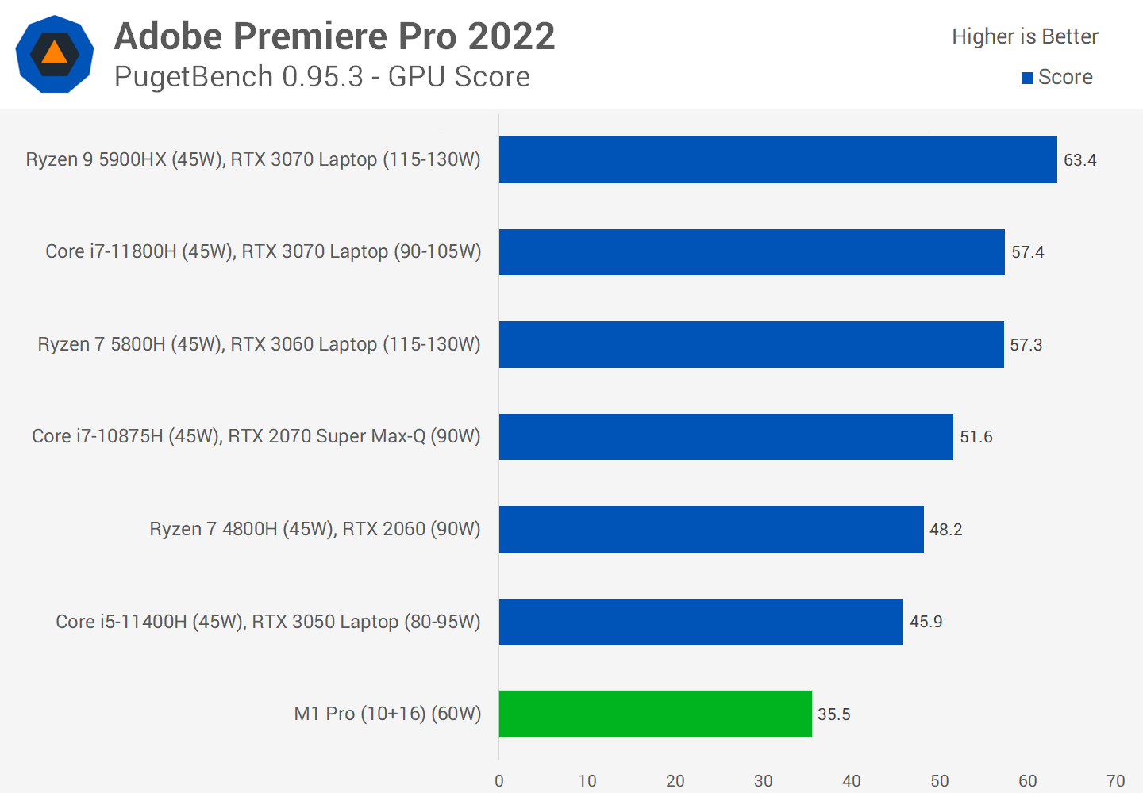

The effects score on the M1 Pro is also rather strong, falling somewhere between the 5900HX and the 5800H in this primarily CPU constrained score. Then we get to the GPU score where performance is below that of the RTX 3050 as expected. I don't have any low-power GPUs in this benchmark yet, and the M1 Pro's 16-core GPU isn't quite up to par with Nvidia's 80W+ GPUs; it trails the RTX 3050 by 23 percent but consumes significantly less power.

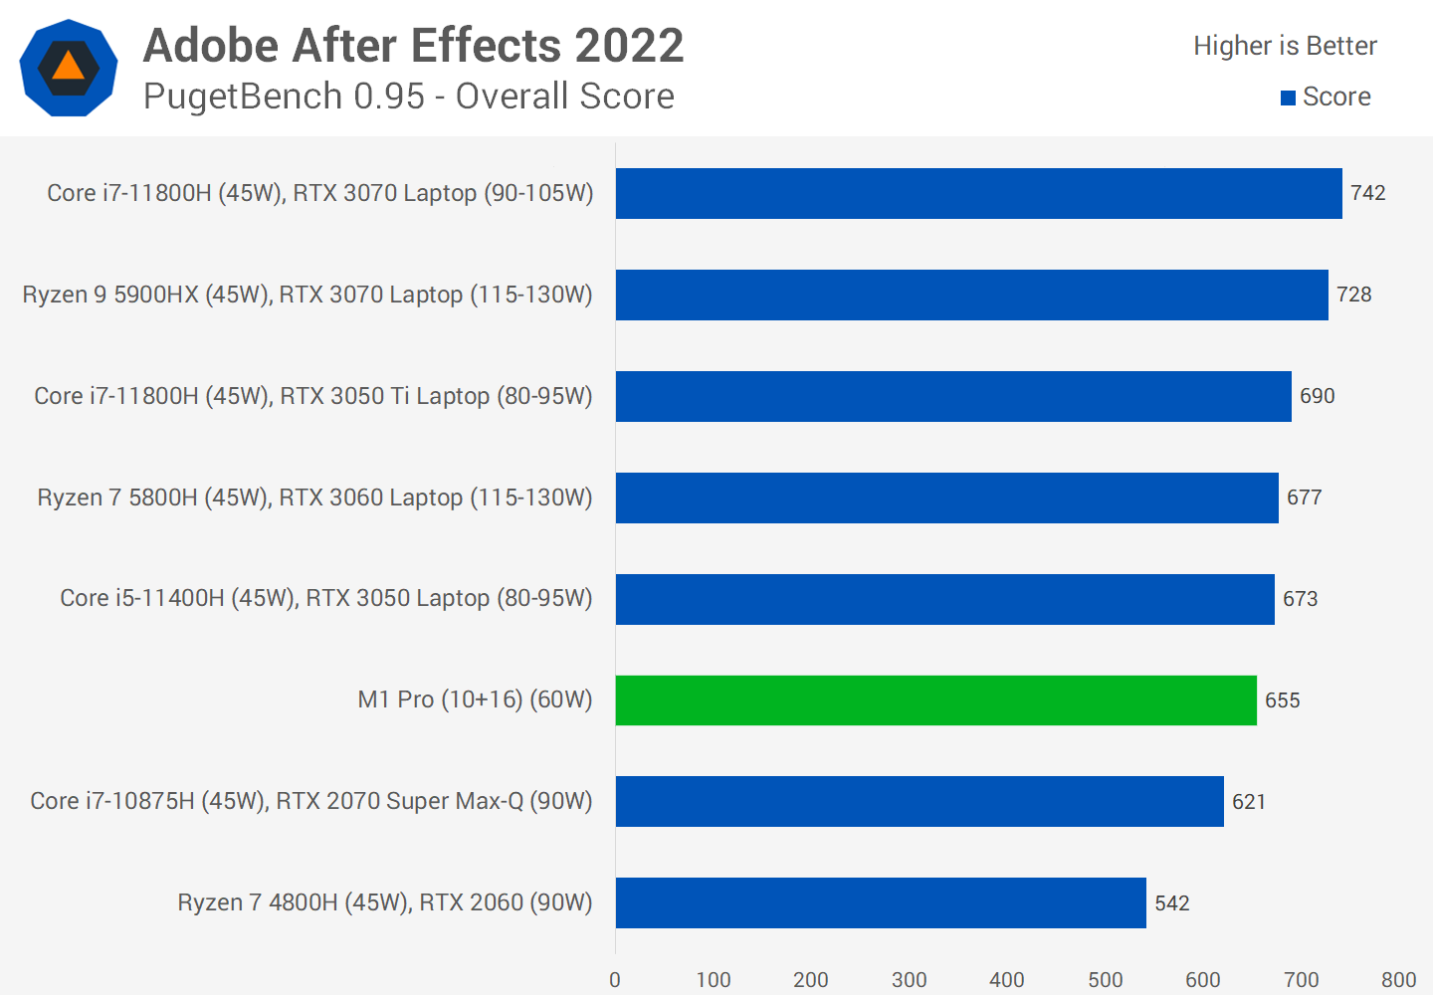

While Premiere has a native Apple Silicon version, After Effects doesn't, therefore Rosetta is required. In PugetBench, the M1 Pro still performs well, surpassing a Ryzen 7 4800H setup with RTX 2060 graphics, but it falls short of the best Intel-based computers.

Although the GPU is used in this benchmark, the final result is primarily influenced by CPU performance, with the 11800H doing particularly well because to its superb single-thread performance. Unfortunately, we were unable to evaluate Photoshop since the PugetBench programme we use isn't currently compatible with the native Apple Silicon version of Photoshop, and I felt it would be unfair to utilise the Intel version instead.

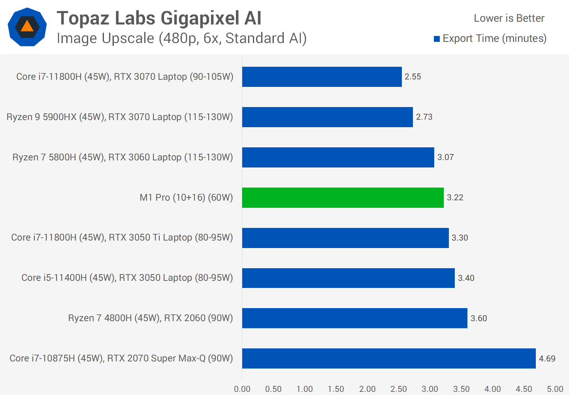

Gigapixel AI picture upscaling, leveraging Topaz Labs' famous technology, is a new addition to our computational benchmarks. This benchmark is performed with GPU acceleration in the quickest feasible setting, which works well with Nvidia RTX 30 series GPUs. The M1 Pro must employ Rosetta 2 emulation, yet it still outperforms the RTX 3060 and RTX 3050 Ti in terms of performance for a low-power arrangement. Although the fastest Windows PC we tested is 26% faster, it is more comparable to the M1 Max.

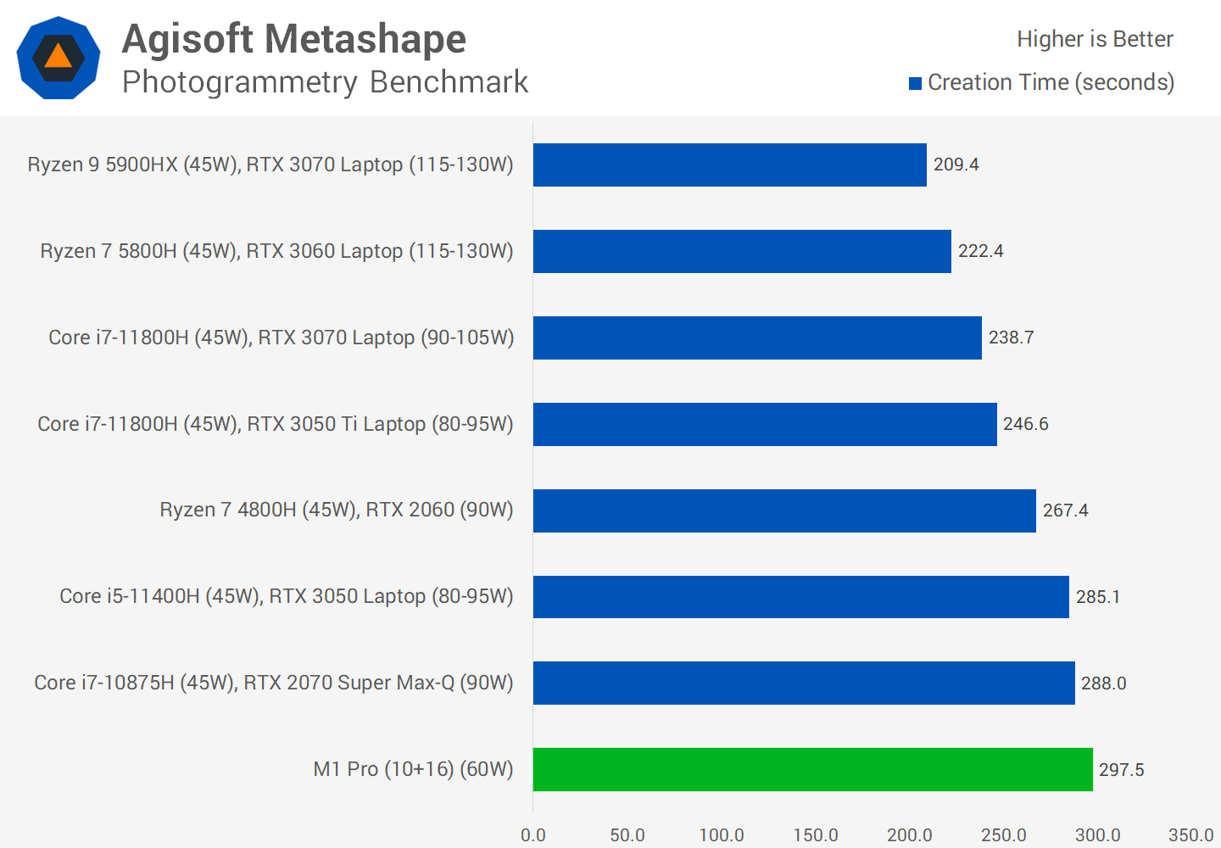

Our last computational benchmark is Agisoft Metashape, a newcomer that uses photogrammetry to convert still photos into 3D models. This is a GPU-accelerated benchmark that walks you through the multi-step process of building a model using sample photos. We're utilising the app's most recent beta version, which has native Apple Silicon compatibility.

The M1 Pro finished last of the setups we tested on this benchmark, but that's not a bad thing because the SoC is just marginally behind far more power-hungry devices with bigger GPUs. For example, although peaking at around 60W of power utilisation in intensive CPU+GPU tasks, the whole M1 Pro package is just 4% slower than a system with Nvidia's RTX 3050 operating at up to 80-95W.

**Gaming Performance**

Next, we'll look at gaming performance in native macOS titles, because the macOS gaming environment is, to put it bluntly, abysmal. Only five of the 23 games we tested on laptops had macOS equivalents, four of which worked on the M1 Pro, and none have native Apple Silicon implementations. This is comparable to the split of my whole game library, where just 16% of titles have macOS versions. That alone indicates you shouldn't buy a MacBook for gaming, but we'll check out the titles that are supported.

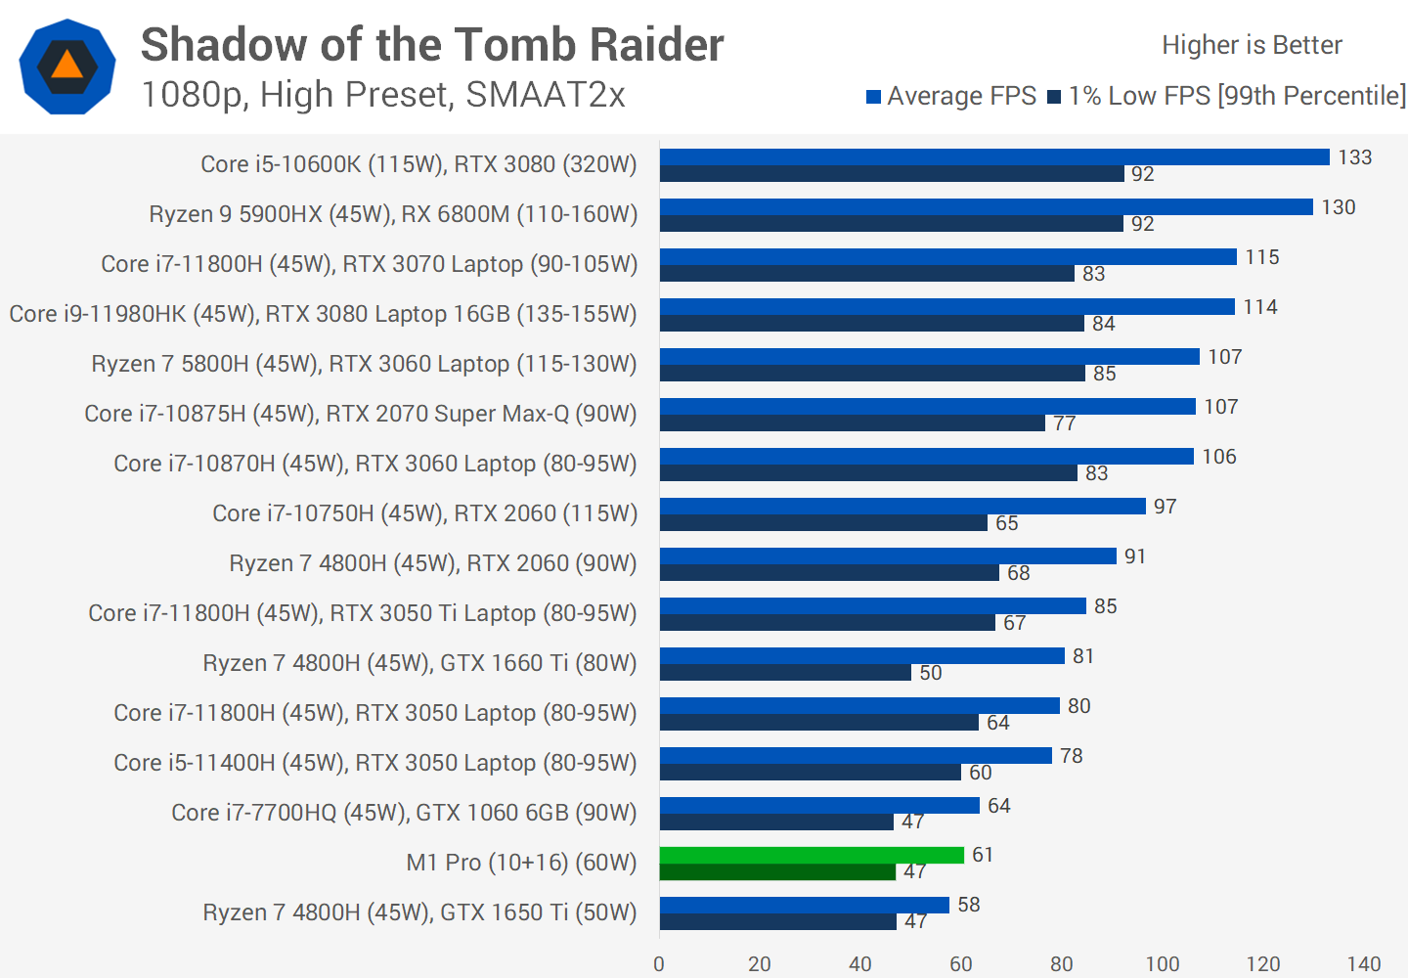

We benchmarked Shadow of the Tomb Raider utilising only the last segment of the in-game benchmark, not the complete run. In this sector, the M1 Pro performed somewhere between the GTX 1650 Ti and the GTX 1060 6GB, which is to be anticipated considering its low power consumption. This Apple Silicon combination is 22% slower than Nvidia's full-power RTX 3050, putting it in the entry-level rung of GPUs we've evaluated.

I should point out that the game benchmarking tools available for macOS are quite limited in comparison to what is currently available on Windows, which has access to strong applications such as OCAT. While these numbers are typical of in-game performance, the precision isn't as good as I'd want, but we just don't have the resources to create our own macOS FPS counting tools.

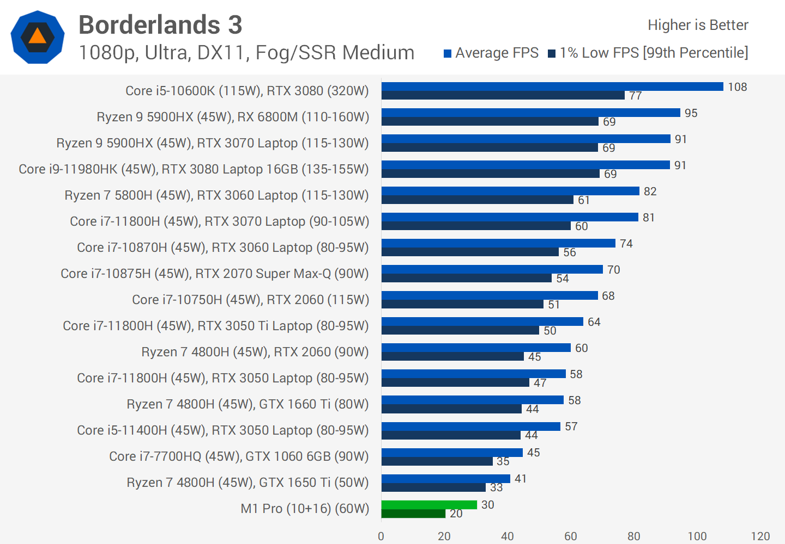

Borderlands 3 will run on the M1 Pro, but it will run poorly, and I'm not sure if this is because the game requires Rosetta 2 to operate, or because the GPU in this chip is weak. The game's performance is well behind that of the GTX 1650 Ti, and at the Ultra settings combo we tried, the game is practically unplayable.

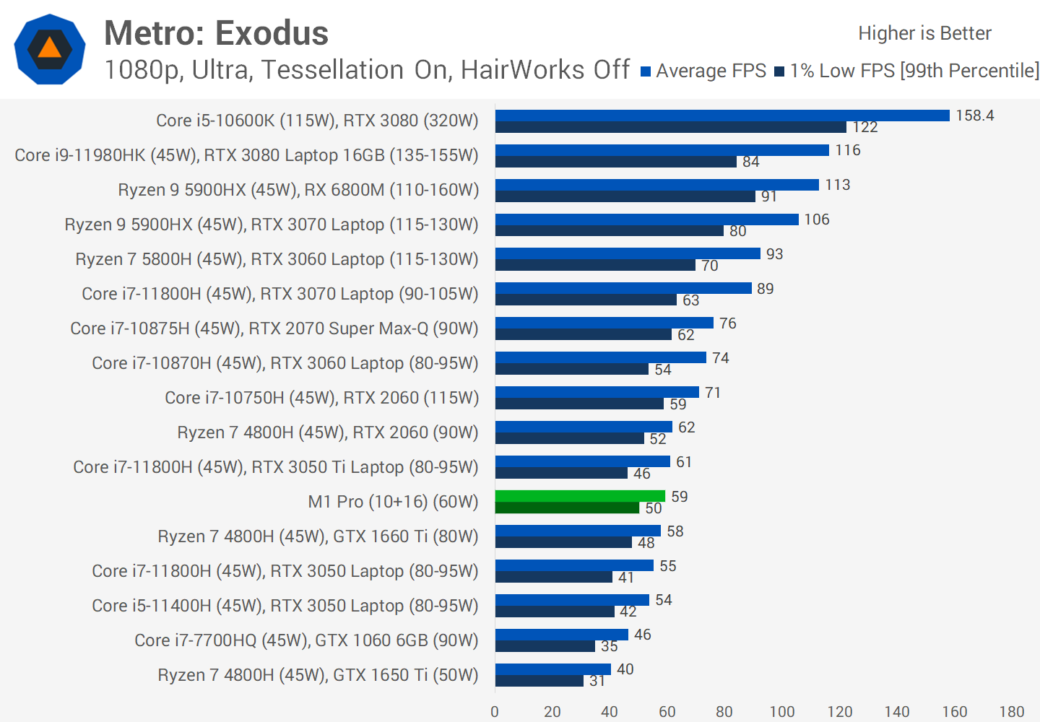

The greatest example of game performance on the M1 Pro is Metro Exodus, however I'm not sure how comparable the game settings are considering the macOS version lacks tessellation and Hairworks choices. But, assuming the game is the same, the M1 Pro performs admirably, falling in between the RTX 3050 and RTX 3050 Ti while playing at 1080p. Apple Silicon, on the other hand, does not support hardware accelerated ray tracing or DLSS, therefore its feature support in this game is inferior to what you'd get on a laptop with an RTX 3050.

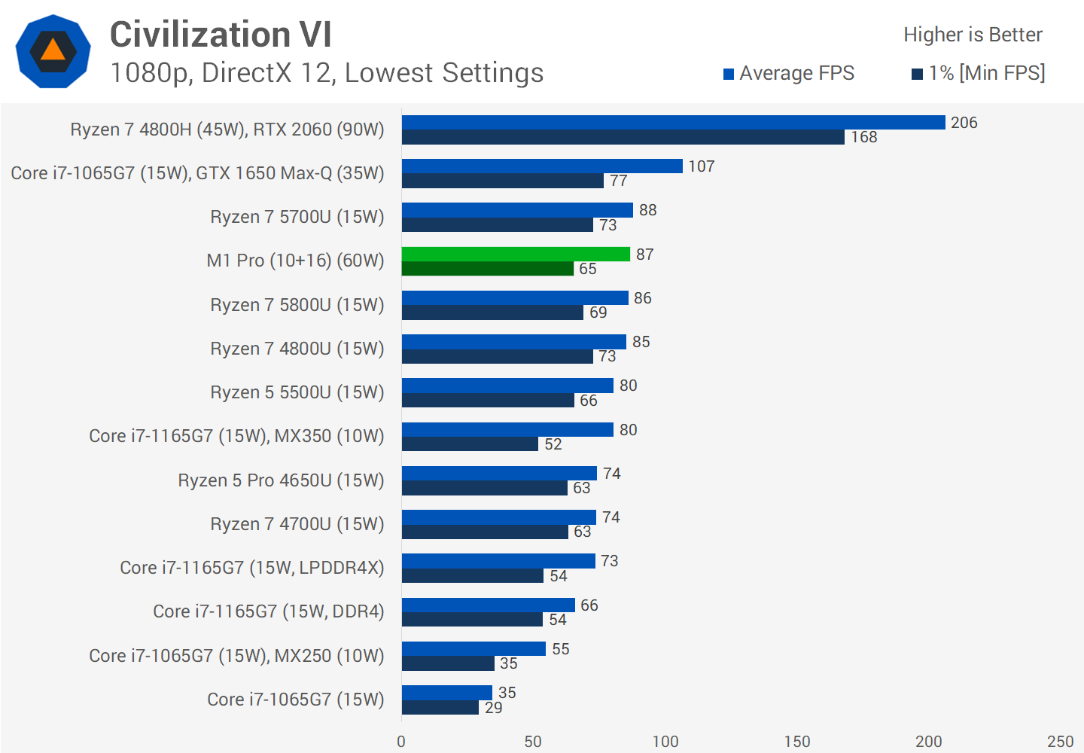

Finally, we have Civilization VI, which we put through its paces on low settings in order to compare integrated graphics. It teaches us about CPU-limited performance with more powerful GPUs. This is another another game where the M1 Pro falls short of even the GTX 1650 Max-Q that we've seen in previous thin and light laptops. This game doesn't appear to be optimised for Apple Silicon in any way, and it might be hampered by the fact that it must run in emulated mode.

**Power Consumption**

Power consumption, as measured at the wall but ignoring idle power usage, is the final area of performance to evaluate. This offers us a good notion of how much power the various system components need when they're working hard, while taking into account changes in displays and other factors.

The first is Cinebench R23 multi-threading, which demonstrates the M1 Pro's exceptional efficiency. Despite surpassing the Ryzen 9 5900HX by a little margin, power consumption was 13W lower during the sustained long-term section of the benchmark, putting it in the 35W class.

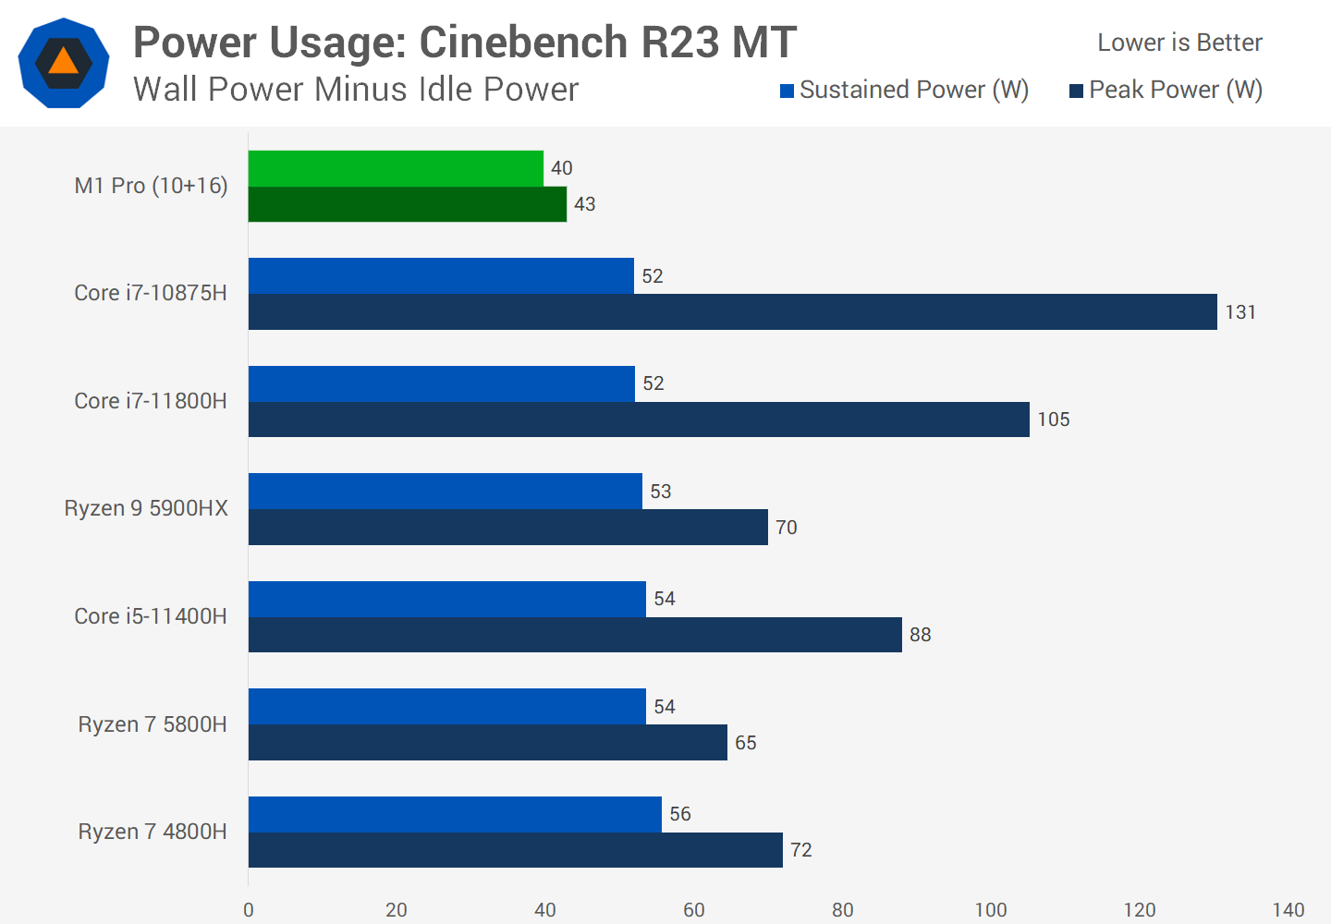

Even more amazing is the fact that many x86 CPUs burst to attain high multi-thread performance for a short period of time, such as in programmes like 7-Zip or Excel. The M1 Pro, on the other hand, manages to deliver competitive performance in those apps despite using just 43W of normalised peak power. The fact that Apple can reach such high performance without using any type of boost or turbo clock is impressive and signals to a design that prioritises efficiency.

In Cinebench single threading, Apple has the most efficiency advantage over its competitors. The performance is comparable to AMD and Intel's finest laptop CPUs, but the power consumption is a factor of ten. When you consider that the newest x86 CPUs are pushing over 20W of power when boosted above 4.0 GHz, using just 7W of electricity is ridiculous.

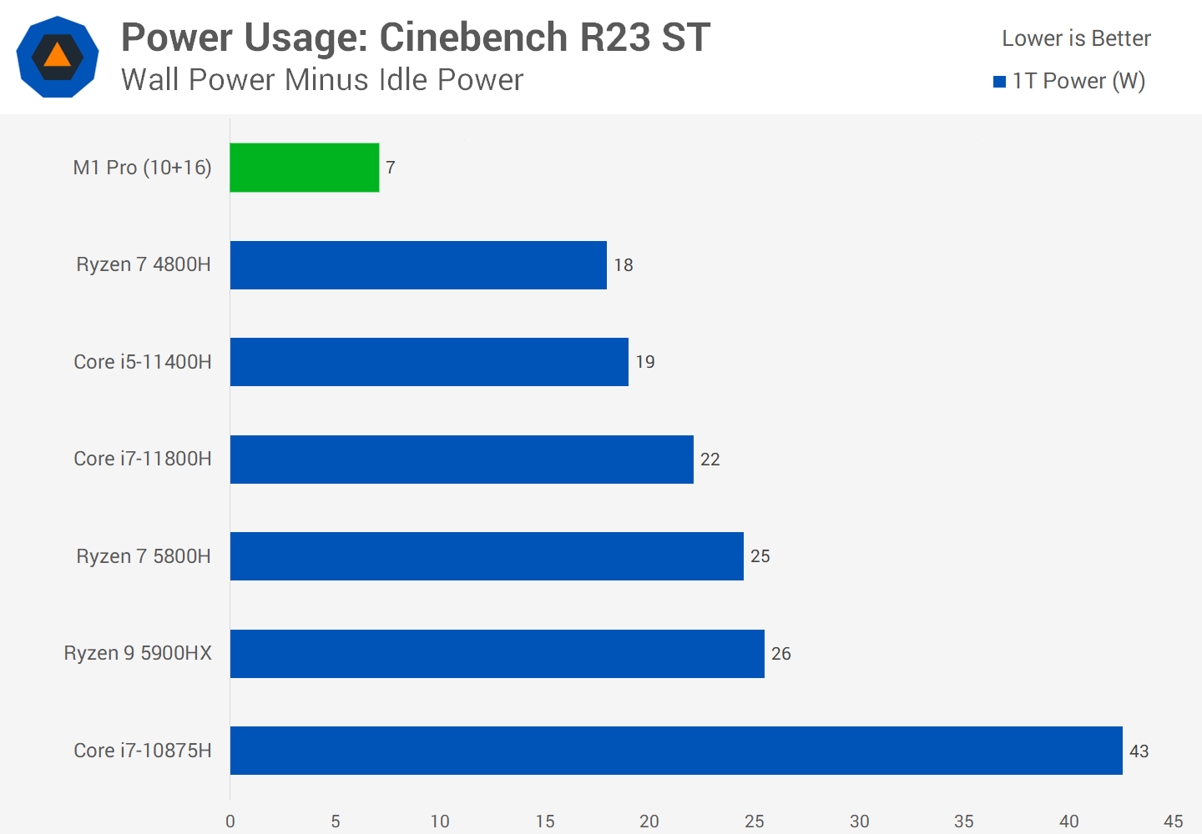

This is why the new MacBooks have such good battery life; they have a significant advantage over their competitors in terms of efficiency while working with sparsely threaded tasks, allowing for the highest performance without losing battery life.

While gaming, the M1 Pro is also quite efficient. During a demanding Shadow of the Tomb Raider portion, peak power consumption was 60W, which was less than half of our RTX 3050 test systems and just slightly more than a Ryzen 9 5900HX with its integrated GPU. In this test, performance was also lower than the RTX 3050, falling 24 percent short, but power consumption was 55 percent lower, putting Apple in the lead in terms of performance per watt. This is why Apple created a monolithic SoC with unified memory, which offers several power advantages.

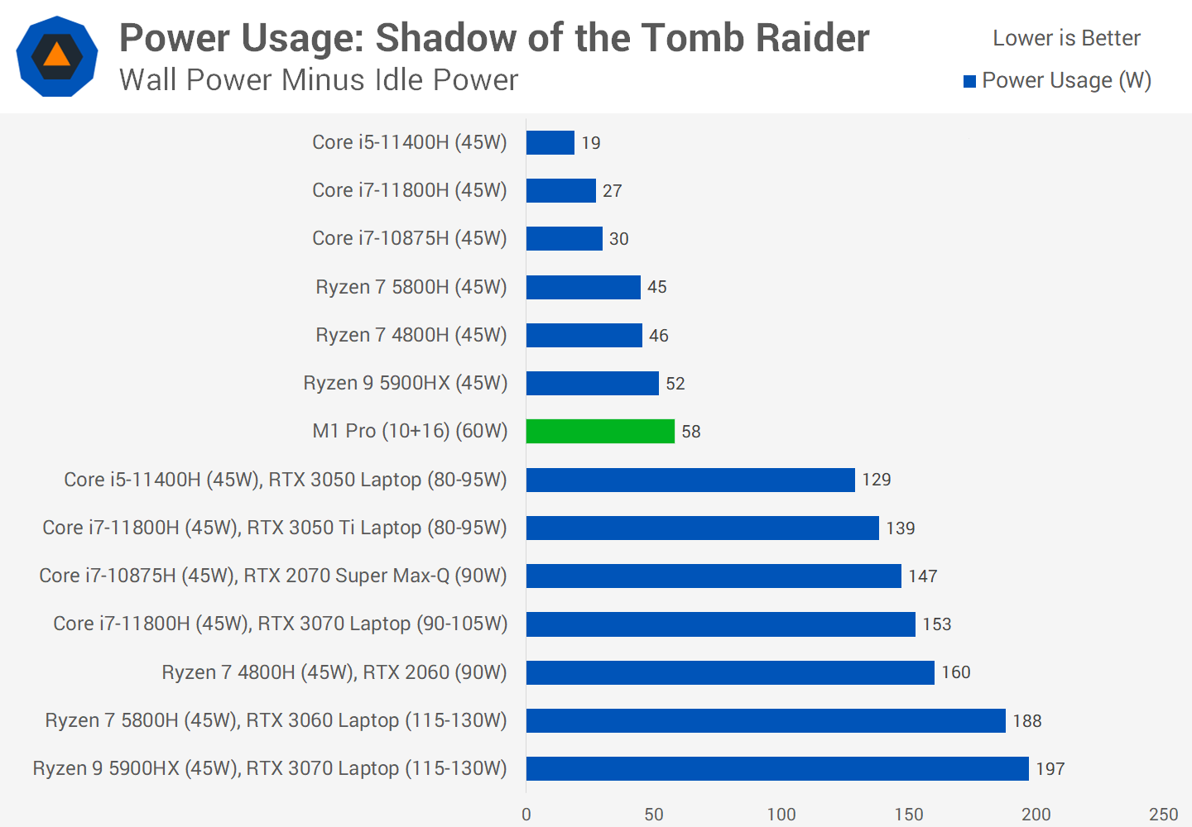

Over the last two weeks, I've been testing the new 16-inch MacBook Pro, which has been a fascinating and entertaining challenge to learn more about macOS and its numerous programmes. Even more intriguing is how the new M1 Pro works in real-world scenarios, so let's have a look at that in what may turn out to be a lengthy conclusion.

**What We Discovered?**

The Apple M1 Pro is a powerful SoC in terms of sheer performance. Although performance varies depending on the application, the CPU is typically comparable with today's finest x86 laptop CPUs from Intel and AMD. The M1 Pro can shatter what's available on Windows-based devices in the best circumstances, when an app can genuinely benefit from the M1 Pro's particular advantages, such as its tremendous memory bandwidth. Other times, performance is generally comparable to Ryzen 9 5900HX and Core i9-11980HK CPUs, and in the worst-case circumstances, such as CPU-based video encoding, it can slip behind. Overall, you're getting current, cutting-edge performance.

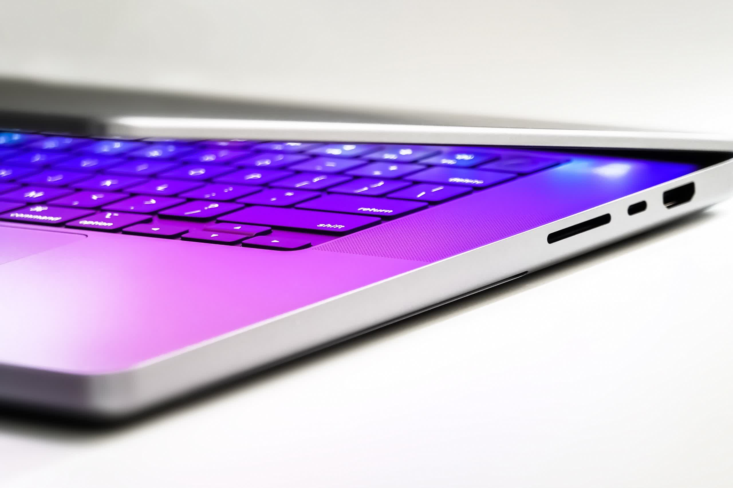

When you have precisely specialised workloads that make use of the M1 Pro's accelerators, Apple can expand its edge even more. One example is video editing with ProRes acceleration, albeit export speed isn't nearly as high as on the top x86 computers with an Nvidia discrete GPU. If you have those kinds of workloads, and I expect a lot of them will be Apple first-party software like Final Cut or Logic, then a MacBook Pro with these new M1 CPUs will provide significant benefits.

However, GPU performance is uneven. It's worth noting that we only tested the M1 Pro version with its 16 core GPU, not the complete M1 Max, which we expect to perform much better. In productivity programmes, the M1 Pro's GPU is about similar to a normal lower-power discrete Nvidia GPU (slower than a full-power RTX 3050), while gaming performance is dismal owing to a multitude of difficulties such as lack of optimization and emulation.

However, while the performance is excellent, it is not the main attraction. It's the M1 Pro's efficiency that puts it in a league of its own. While performance may be comparable to a Ryzen 9 5900HX in intensive multi-threaded CPU programmes, power consumption is at least 10W lower, making 35W-class CPUs the most comparable alternative. Apple simply outperforms today's top x86 architectures at the same power level, an advantage that grows in lightly threaded and GPU-intensive programmes. The whole design is based on efficiency, with good battery life as a result.

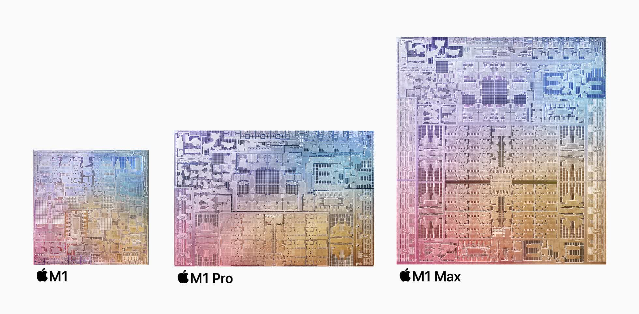

Of course, this is to be anticipated, considering that Apple's processors are a full process node ahead of x86 chips: they employ TSMC's 5nm, compared to AMD's 7nm and Intel's own 10nm SuperFin. Apple should be ahead with that kind of edge, and they are. The M1 Pro benefits from this in two ways: performance isn't affected by battery life, and the processors are so efficient that they can operate at full power without needing to be plugged in. Second, under typical workloads, the new 16-inch MacBook Pro is nearly silent, whereas many Windows laptops crank up their fans to jet engine levels, especially in programmes that employ a discrete GPU.

When we're talking about the best performance a laptop can offer, the M1 Pro destroys its competitors when we're free roaming away from a charger. It's a more complicated situation when we're talking about the best performance a laptop can offer when we're talking about the best performance a laptop can offer when we're talking about the best performance a laptop can offer. Because some of the margins by which the M1 Pro wins are so small, switching an x86 laptop to its "high-performance, high-power consumption" option causes the script to switch back to AMD or Intel.

While the M1 Pro is 4 percent quicker in Cinebench than the 5900HX when configured at 45W, AMD may reclaim the lead when the 5900HX's efficiency is blown out of the water at 70W or more, and can be up to 10% faster.

If you care less about battery life and more about getting your chores and responsibilities done as quickly as possible, this is important. Windows computers may still have an advantage here, particularly if you obtain one with a powerful discrete GPU, considering that the M1 Pro's GPU isn't great and the M1 Max is exorbitant.

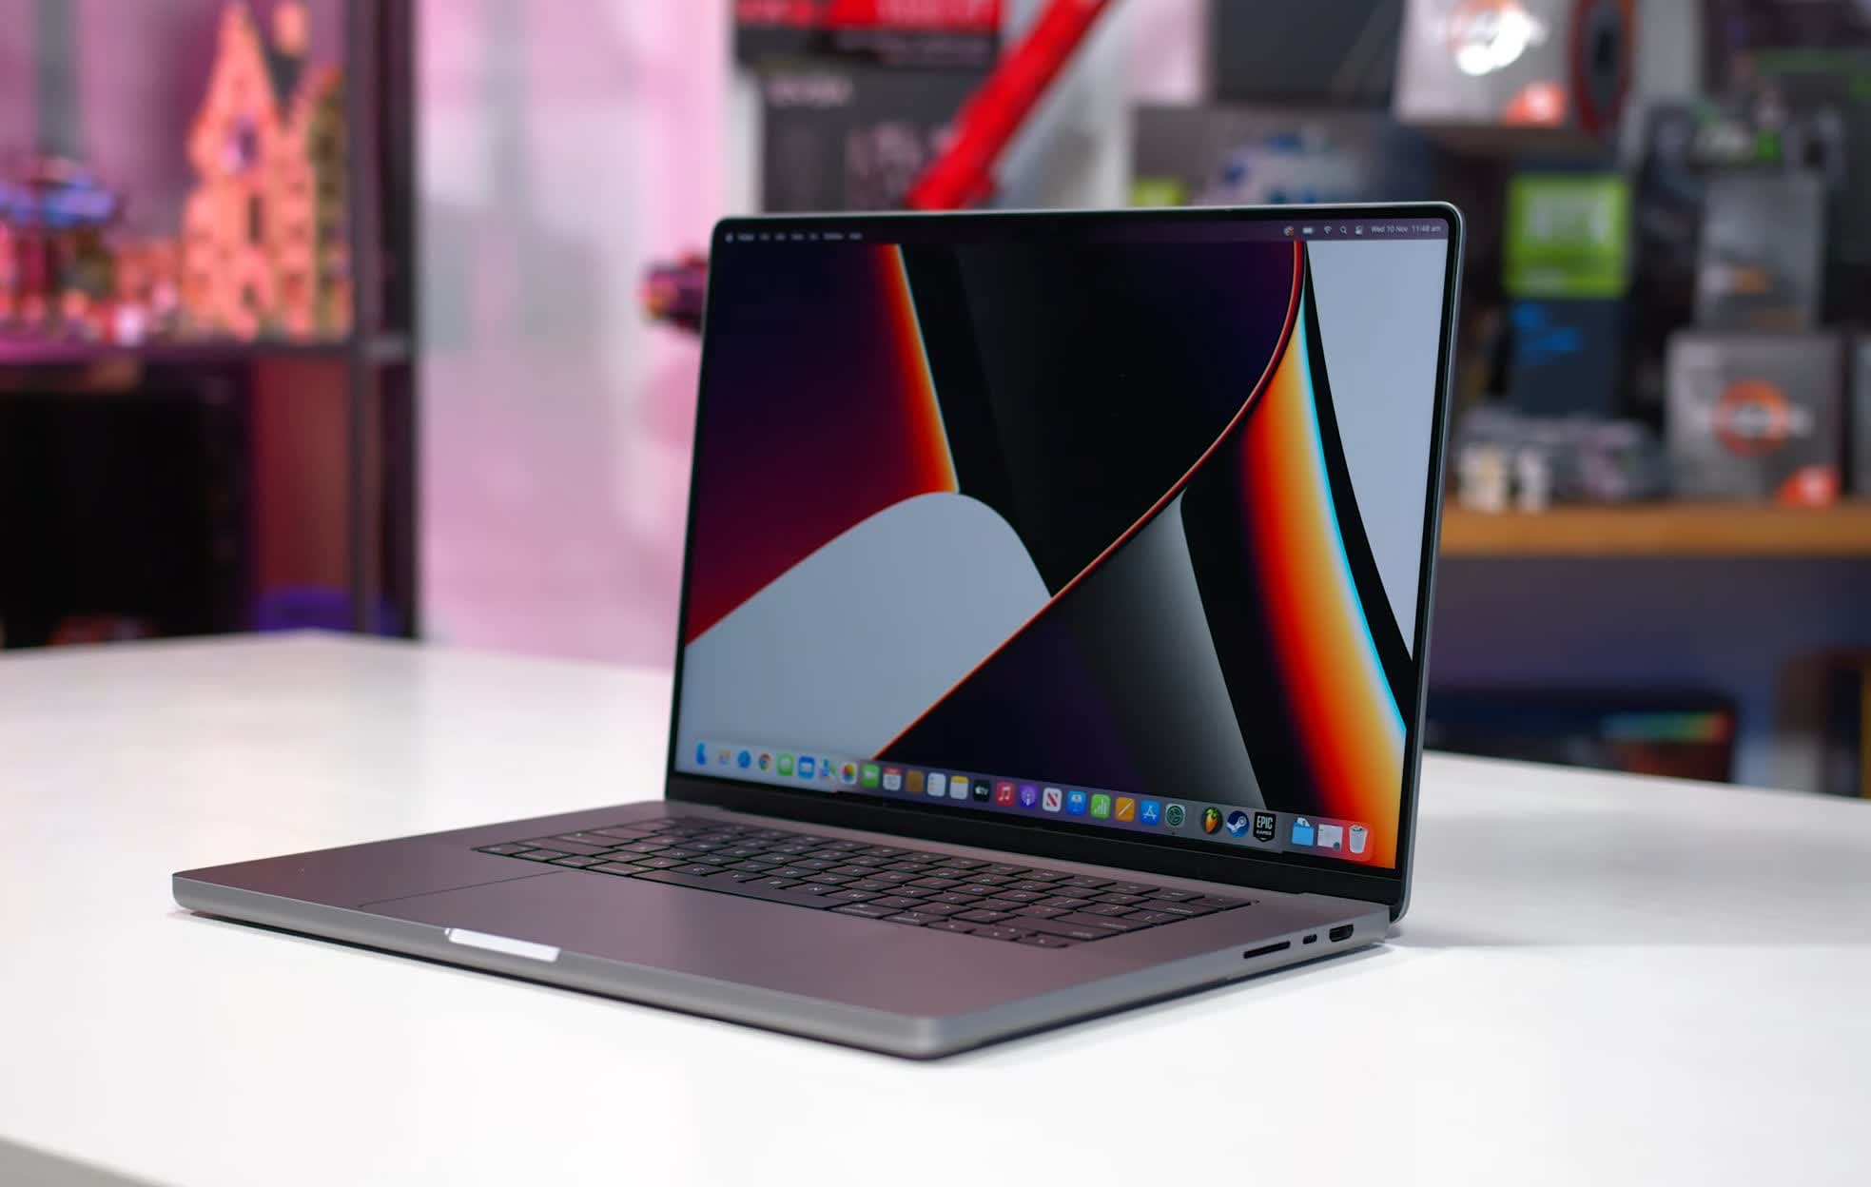

We're also not in a situation where the M1 Pro in a MacBook can beat or even come close to a desktop workstation in most programmes. I know some people say this, but with CPUs like the Ryzen 9 5950X and Core i9-12900K on the market, it's simply not true.

While the M1 Pro isn't orders of magnitude quicker than today's greatest Windows systems (particularly on the desktop), it is much faster than last-generation MacBook Pros with Intel processors. Apple's prior 9th-gen hardware is sluggish by today's standards; in early 2020, AMD's Ryzen 4000 series was comfortably surpassing it in multi-thread programmes, and performance has increased much more since then. So, Apple users will see a significant performance boost, with at least 50% higher performance in pure CPU-intensive applications and much more in specialised programmes that benefit from the M1 Pro architecture.

So, while the M1 Pro's performance and efficiency are excellent, I do have a few gripes.

It still feels like consumers are beta testing Apple Silicon while using the MacBook Pro with a variety of work applications. Despite the fact that the first M1-powered laptops were on sale a year ago, there are still a lot of programmes that haven't been upgraded to use the M1 family natively. Rosetta 2 is a great programme, but it comes at a cost in terms of performance and efficiency. Furthermore, several updated softwares are either missing functionality (such as Blender's lack of GPU rendering capability) or operate poorly (such as FL Studio) when compared to the identical app on Windows. That's not ideal for a production-oriented system, as users may require a certain app for their workflow and expect such applications to function well in order to maximise productivity.

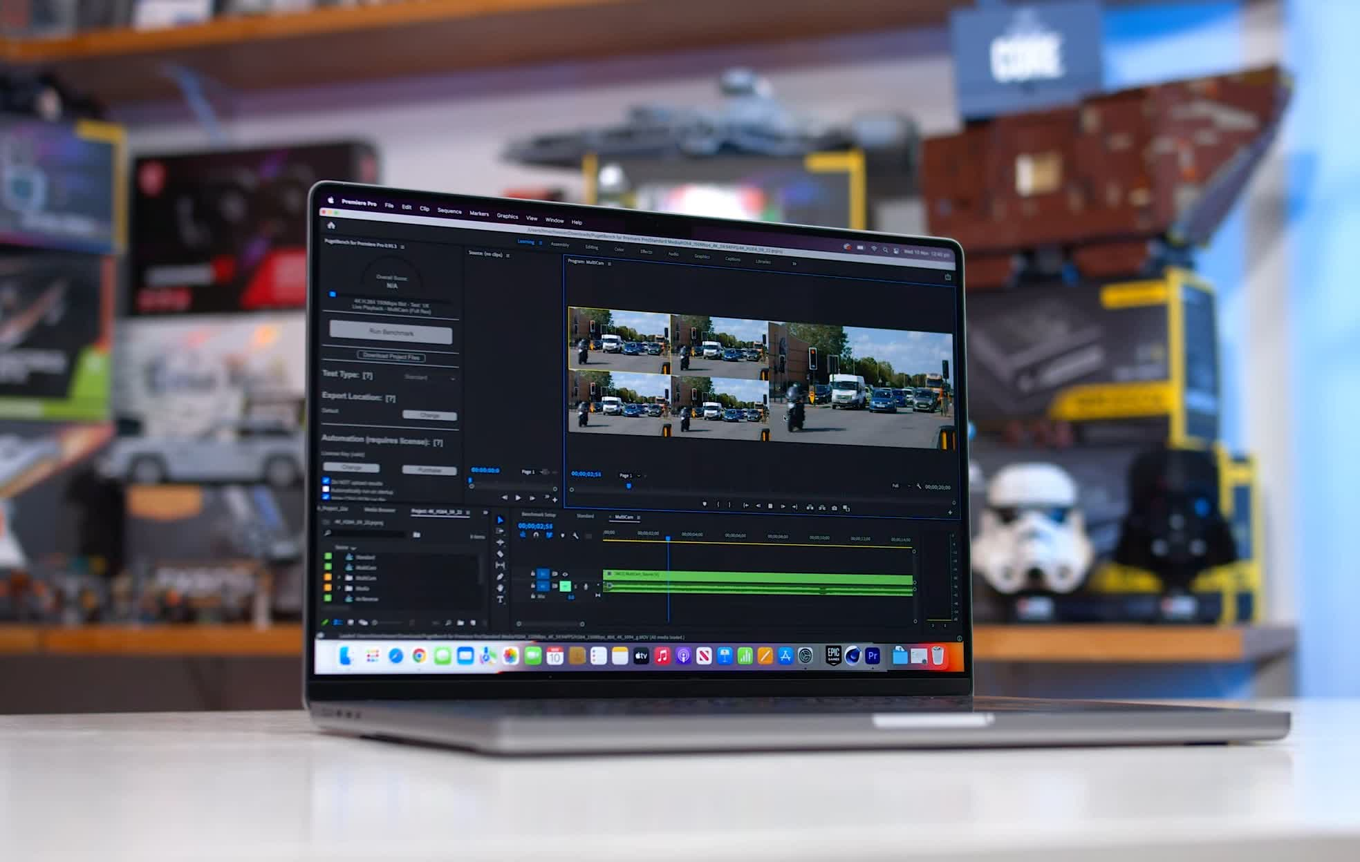

Gaming on macOS is also a bit of a joke, both in terms of compatibility and performance. One of the nicest aspects of purchasing a high-performance Windows laptop for productivity is that you can sneak in some gaming on the side, making those devices rather adaptable given the large library of compatible titles. Macs lack such flexibility, and the M1 Pro is a horrible gaming machine.

Finally, there is the question of cost. The entire M1 Pro starts at £1827 for laptops, while the full M1 Max costs at least £2410 (or more if you want decent SSD capacity). Upgrades to memory and storage are exorbitantly priced: £293 more to go from 16 to 32GB of RAM, and £143 more to go from a 512GB SSD to 1TB, is outrageous, and made much worse by the lack of user upgradeability. With this release, Apple is reaming you for all you've got.